# Database design

## **Tables: At the core of every database**

 let's delve into one of the most important concepts behind databases: tables.

 Redundancy in the university_professors table

As you can see, this professor is repeated in the first three records. Also, his university, the "ETH Lausanne", is repeated a couple of times – because he only works for this university. However, he seems to have affiliations with at least three different organizations. So, there's a certain redundancy in that table. The reason for this is that the table actually contains entities of at least three different types. Let's have a look at these entity types.

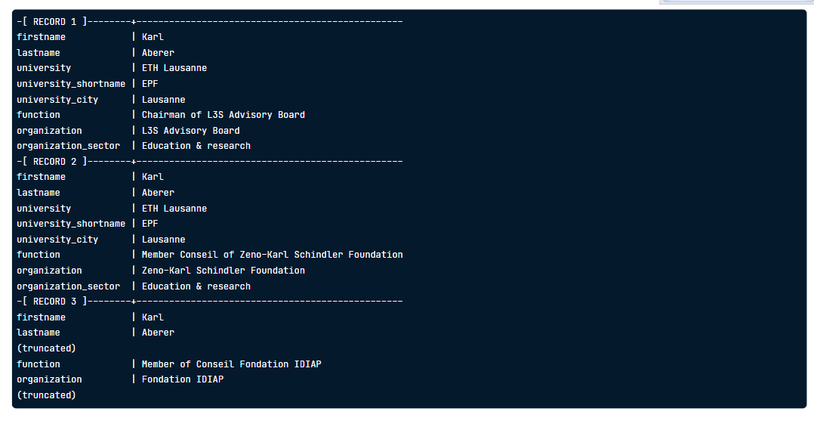 Actually the table stores professors, highlighted in blue, universities, highlighted in green, and organizations, highlighted in brown. There's also this column called "function" which denotes the role the professor plays at a certain 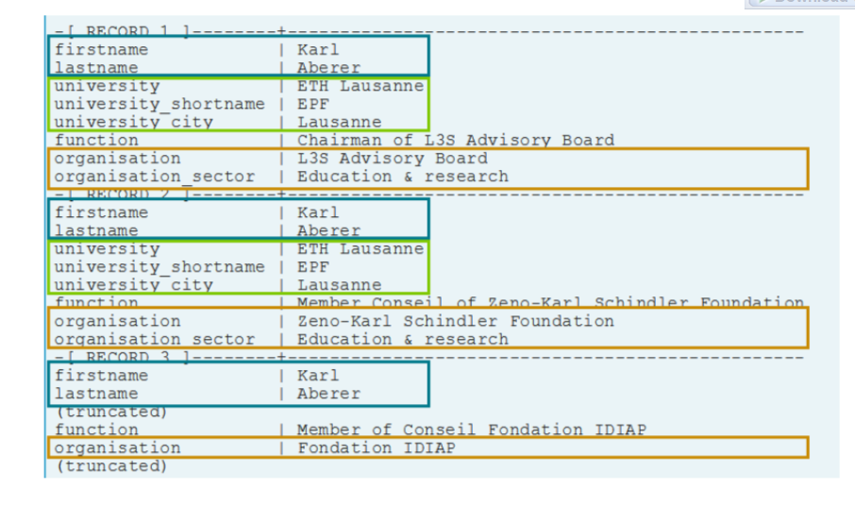 Currently: One "entity type" in the database

Let's look at the current database once again. The graphic used here is called an entity-relationship diagram. Squares denote so-called entity types, while circles connected to these denote attributes (or columns). So far, we have only modeled one so-called entity type – "university_professors". However, we discovered that this table actually holds many different entity types... 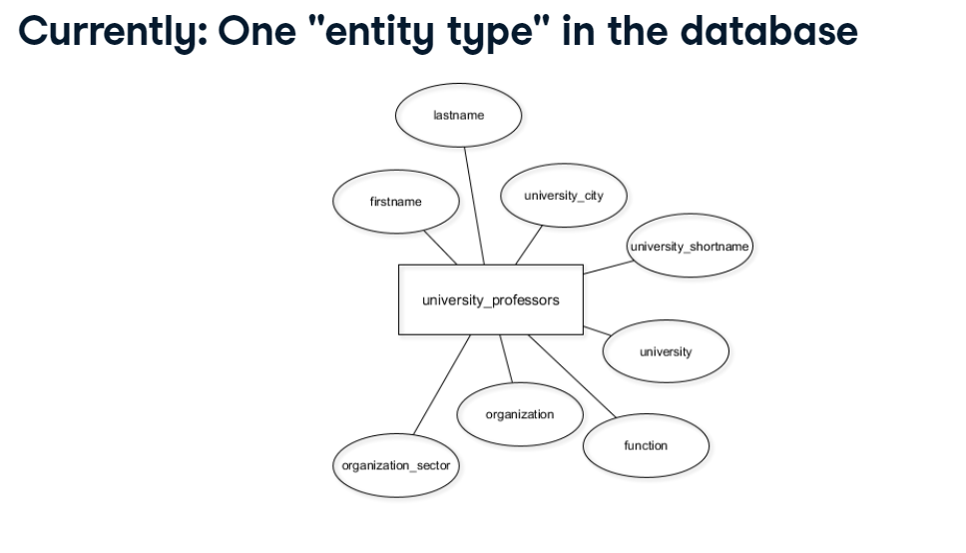

A better database model with three entity types

...so this updated entity-relationship model on the right side would be better suited. It represents three entity types, "professors", "universities", and "organizations" in their own tables, with respective attributes. This reduces redundancy, as professors, unlike now, need to be stored only once. Note that, for each professor, the respective university is also denoted through the "university_shortname" attribute. However, one original attribute, the "function", is still missing.

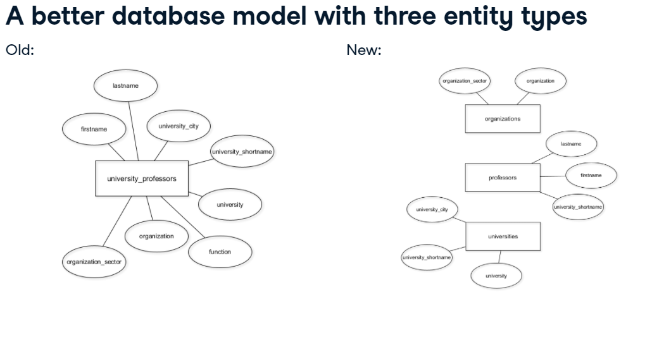

A better database model with four entity types

As you know, this database contains affiliations of professors with third-party organizations. The attribute "function" gives some extra information to that affiliation. For instance, somebody might act as chairman for a certain third-party organization. So the best idea at the moment is to store these affiliations in their own table – it connects professors with their respective organizations, 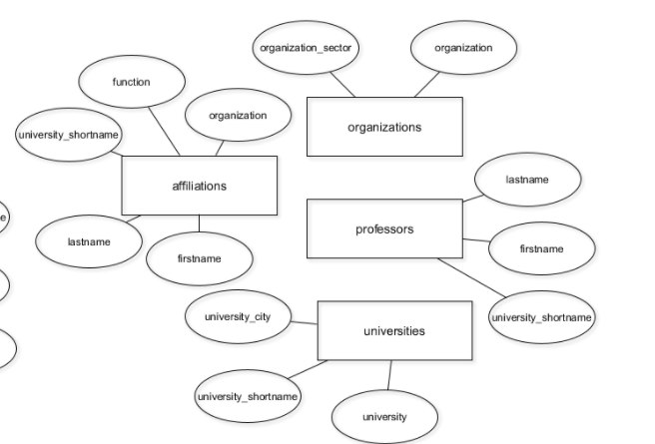

 The current database model

At this moment, only the "university_professors" table holds data. The other four, shown in red, are still empty. In the remainder of this chapter, you will migrate data from the green part of this diagram to the red part, moving the respective entity types to their appropriate tables. In the end, you'll be able to delete the "university_professors" table.

Only store DISTINCT data in the new tables

One advantage of splitting up "university_professors" into several tables is the reduced redundancy. As of now, "university_professors" holds 1377 entries. However, there are only 1287 distinct organizations, as this query shows. Therefore, you only need to store 1287 distinct organizations in the new "organizations" table.

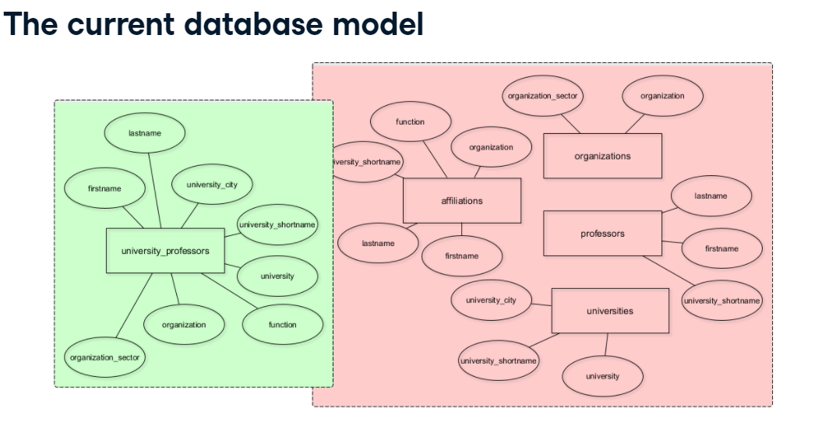 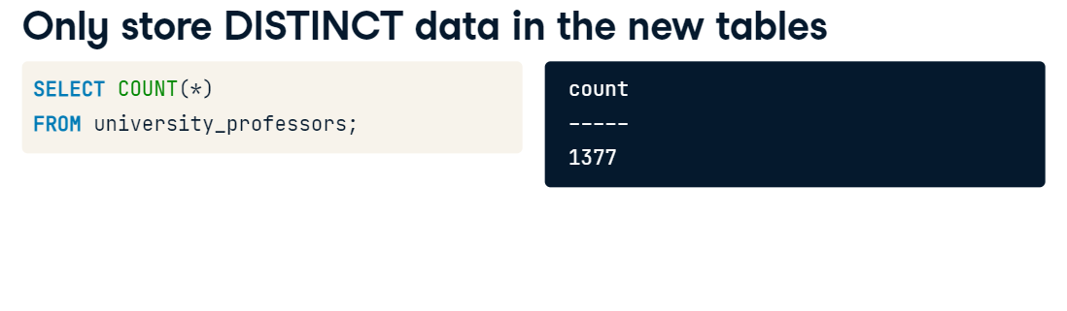

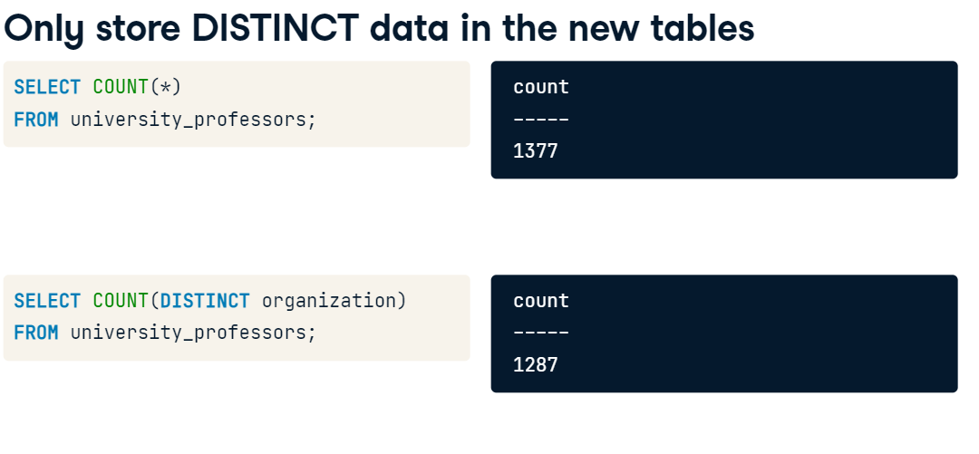

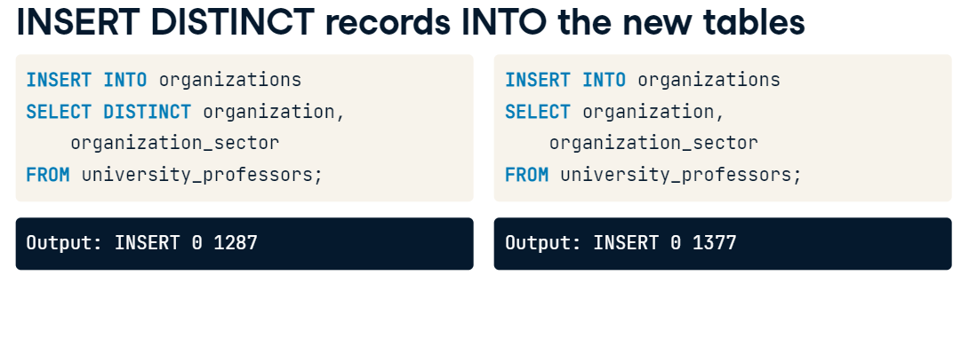 RENAME a COLUMN in affiliations

Before you start migrating the table, you need to fix some stuff! In the last lesson, I created the "affiliations" table for you. Unfortunately, I made a mistake in this process. Can you spot it? The way the "organisation" column is spelled is not consistent with the American-style spelling of this table, using an "s" instead of a "z". In the first exercise after the video, you will correct this with the known "ALTER TABLE" syntax. You do this with the RENAME COLUMN command by specifying the old column name first and then the new column name, i.e., "RENAME COLUMN old_name TO new_name".

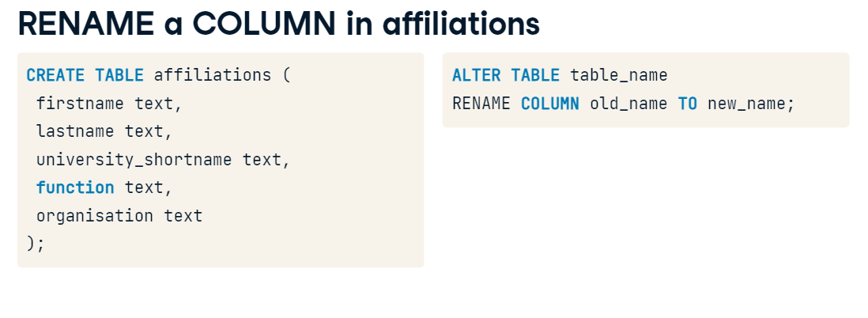  DROP a COLUMN in affiliations

Also, the "university_shortname" column is not even needed here. So I want you to delete it. The syntax for this is again very simple, you use a "DROP COLUMN" command followed by the name of the column. Dropping columns is straightforward when the tables are still empty, so it's not too late to fix this error. But why is it an error in the first place?

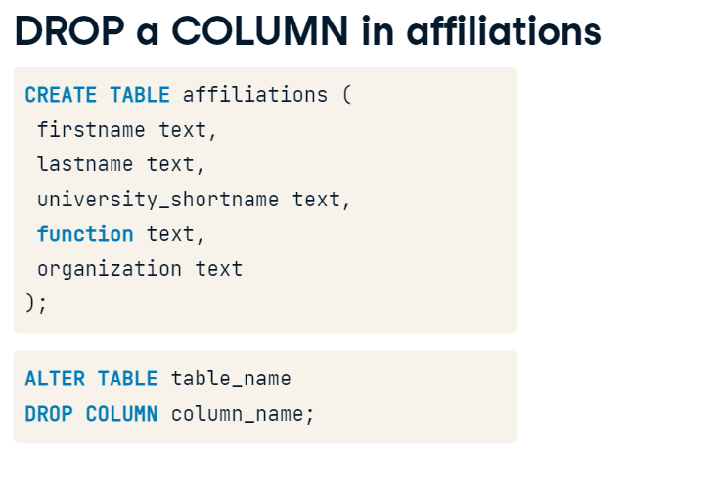Well, I queried the "university_professors" table and saw that there are 551 unique combinations of first names, last names, and associated universities. I then queried the table again and only looked for unique combinations of first and last names. Turns out, this is also 551 records. This means that the columns "firstname" and "lastname" uniquely identify a professor. 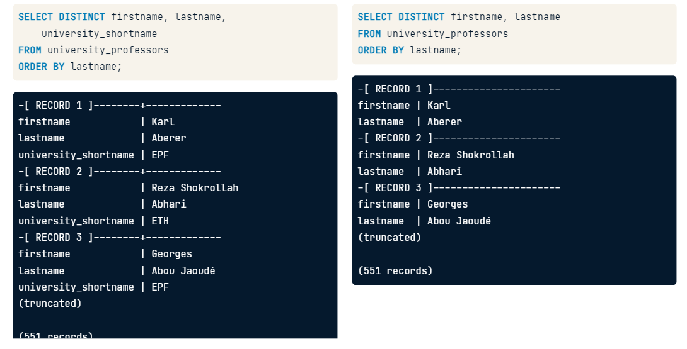 So the "university_shortname" column is not needed in order to reference a professor in the affiliations table. You can remove it, and this will reduce the redundancy in your database again. In other words: The columns "firstname", "lastname", "function", and "organization" are enough to store the affiliation a professor has with a certain organization. 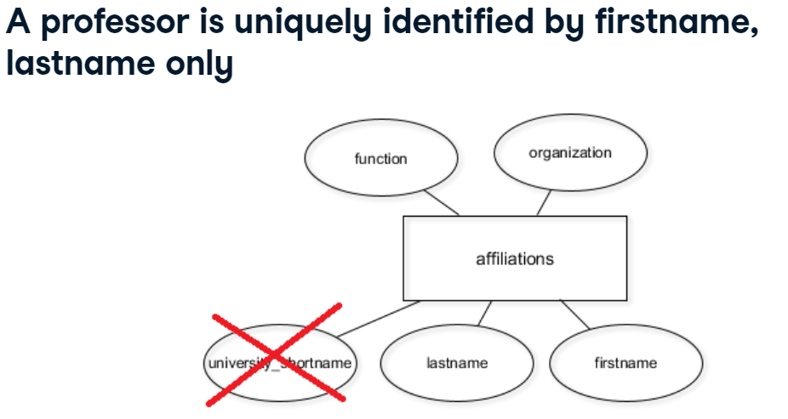

### Model 1:N relationships with foreign keys

The current database model

Here's your current database model. The three entity types "professors", "organizations", and "universities" all have primary keys – but "affiliations" doesn't, for a specific reason that will be revealed in this chapter. 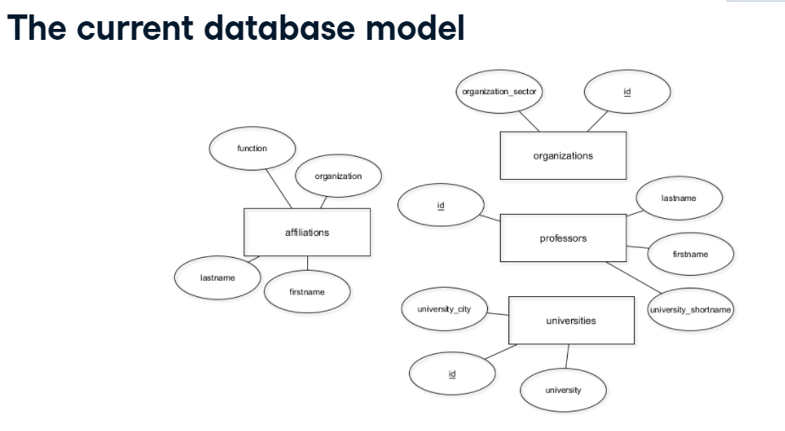

The next database model

Next up, you'll model a so-called relationship type between "professors" and "universities". As you know, in your database, each professor works for a university. In the ER diagram, this is drawn with a rhombus. The small numbers specify the cardinality of the relationship: a professor works for at most one university, while a university can have any number of professors working for it – even zero.

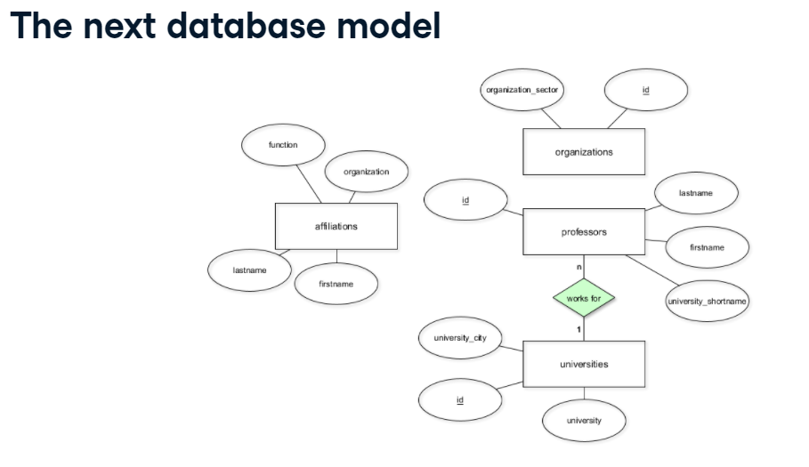  Implementing relationships with foreign keys

Such relationships are implemented with foreign keys. Foreign keys are designated columns that point to a primary key of another table. There are some restrictions for foreign keys. First, the domain and the data type must be the same as one of the primary key. Secondly, only foreign key values are allowed that exist as values in the primary key of the referenced table. This is the actual foreign key constraint, also called "referential integrity". You'll dig into referential integrity at the end of this chapter. Lastly, a foreign key is not necessarily an actual key, because duplicates and "NULL" values are allowed. Let's have a look at your database.

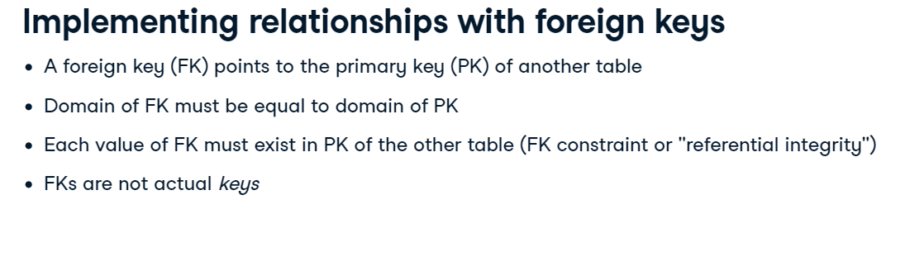

So you've added a 1:N-relationship between professors and universities. Such relationships have to be implemented with one foreign key in the table that has at most one foreign entity associated. In this case, that's the "professors" table, as professors cannot have more than one university associated. Now, what about affiliations? We know that a professor can have more than one affiliation with organizations, for instance, as a chairman of a bank and as a president of a golf club. On the other hand, organizations can also have more than one professor connected to them. Let's look at the entity-relationship diagram that models this.

The final database model

There are a couple of things that are new. First of all, a new relationship between organizations and professors was added. This is an N:M relationship, not an 1:N relationship as with professors and universities. This depicts the fact that a professor can be affiliated with more than one organization and vice versa. Also, it has an own attribute, the function. Remember that each affiliation comes with a function, for instance, "chairman". The second thing you'll notice is that the affiliations entity type disappeared altogether. For clarity, I still included it in the diagram, but it's no longer needed. However, you'll still have four tables: Three for the entities "professors", "universities" and "organizations", and one for the N:M-relationship between "professors" and "organizations".

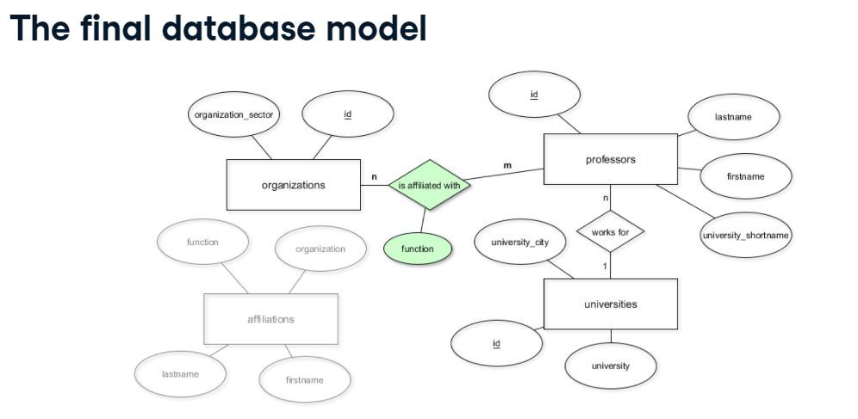 How to implement N:M-relationships

Such a relationship is implemented with an ordinary database table that contains two foreign keys that point to both connected entities. In this case, that's a foreign key pointing to the "professors.id" column, and one pointing to the "organizations.id" column. Also, additional attributes, in this case "function", need to be included. If you were to create that relationship table from scratch, you would define it as shown. Note that "professor_id" is stored as "integer", as the primary key it refers to has the type "serial", which is also an integer. On the other hand, "organization_id" has "varchar(256)" as type, conforming to the primary key in the "organizations" table. One last thing: Notice that no primary key is defined here because a professor can theoretically have multiple functions in one organization. One could define the combination of all three attributes as the primary key in order to have some form of unique constraint in that table, but that would be a bit over the top.

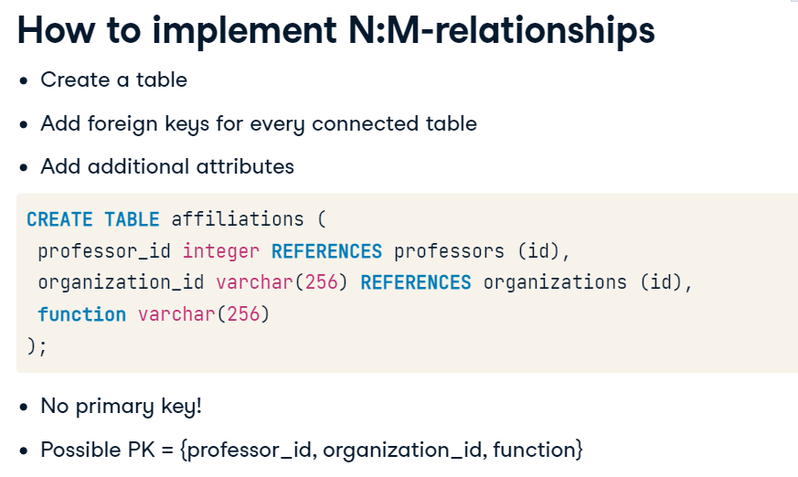 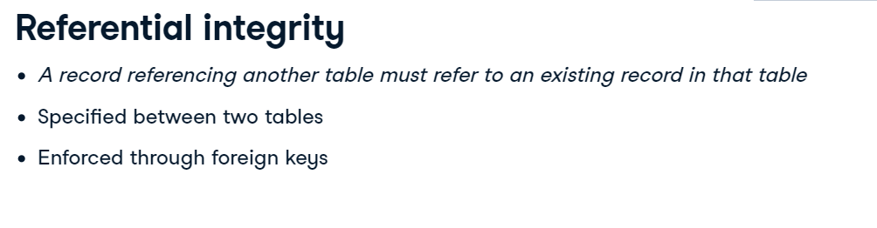 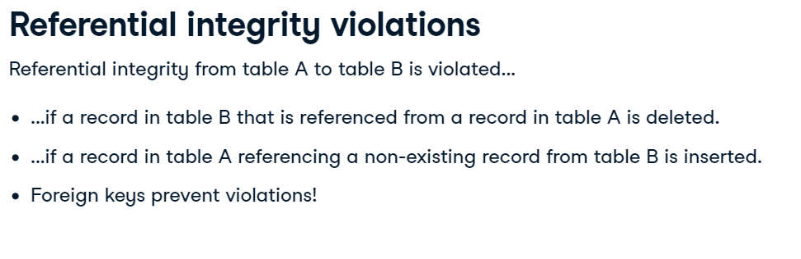

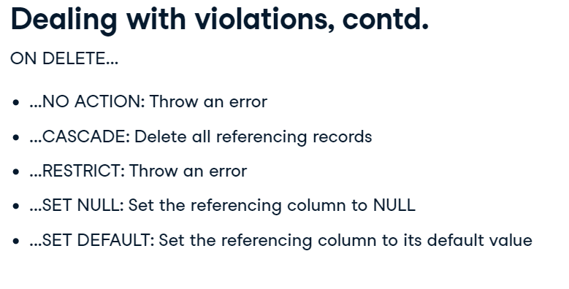

## **OLTP and OLAP**

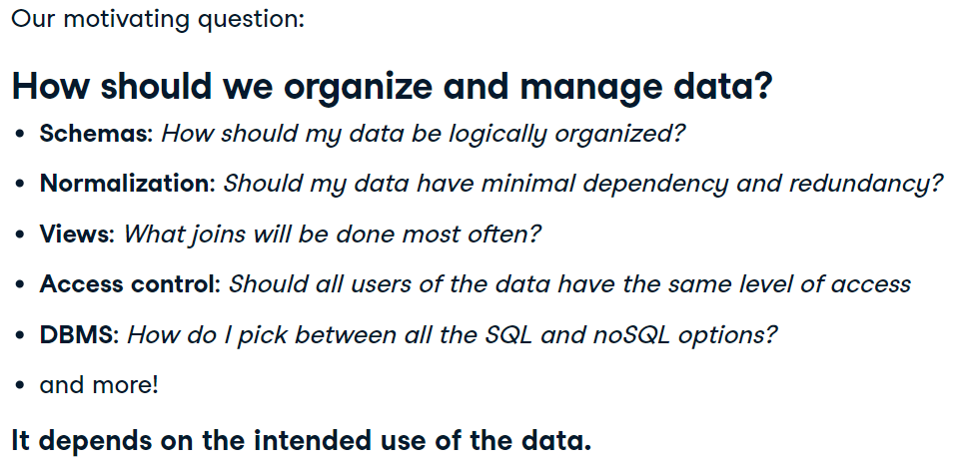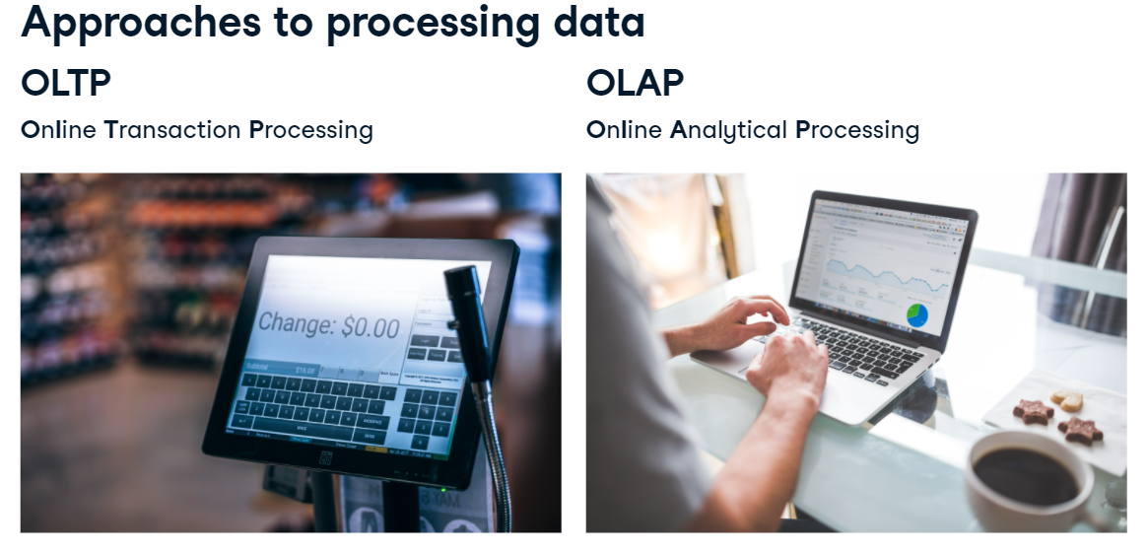Some concrete examples

Before going into formal definitions, let's look at some use cases of each. Say you are in charge of data management at a bookstore. You would use an OLTP approach to keep track of the prices of books, while to analyze the most profitable books, an OLAP approach would be more appropriate. To keep track of all customer transactions, you would use an OLTP approach to insert sales as customers finish paying. However, if you wanted to do sophisticated analysis on sales, like most loyal customers - you would use OLAP. An OLTP database would be used to track when employees have worked, while to run an analysis on who deserves employee of the month, you would need to switch over to OLAP. Are you starting to see their differences? OLTP focus on supporting day-to-day operations, while OLAP tasks are vaguer and focus on business decision making.

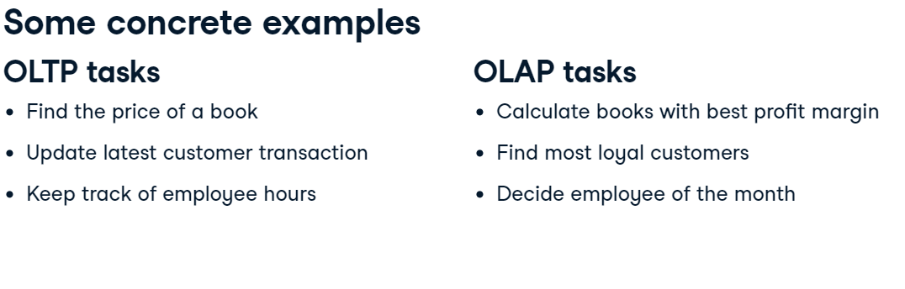OLAP vs. OLTP

This is a nice summary of OLAP and OLTP. The OLTP systems are application-oriented, like for bookkeeping for example. OLAP systems are oriented around a certain subject that's under analysis, like last quarter's book sales. The data in OLTP systems can be seen as a current snapshot of transactions that are archived often. The data in OLAP systems tend to be data from over a large period of time that has been consolidated for long-term analysis. This means OLAP tends to have more data than OLTP. As we saw in the bookstore example, the commonly executed OLTP queries are simpler and require a quick query or update. On the other hand, OLAP systems used for analysis require more complex queries. In terms of how these approaches are being used, OLTP systems are used by more people throughout a company and even a company's customers, while OLAP systems are typically used by only analysts and data scientists at a company.

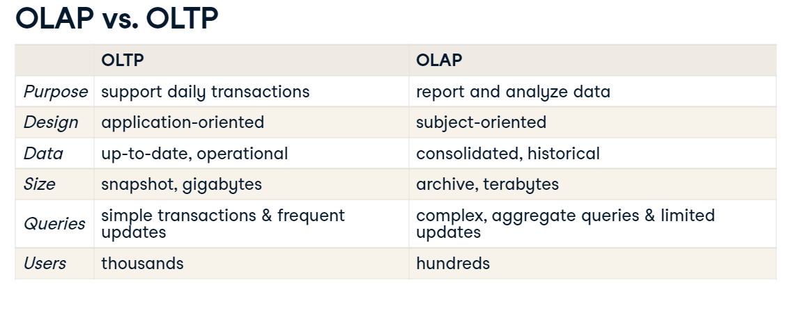Working together

OLAP and OLTP systems work together; in fact, they need each other. OLTP data is usually stored in an operational database that is pulled and cleaned to create an OLAP data warehouse. We'll get more into data warehouses and other storage solutions in the next video. Without transactional data, no analyses can be done in the first place. Analyses from OLAP systems are used to inform business practices and day-to-day activity, thereby influencing the OLTP databases.

Takeaways

To wrap up, here's what you should take away from this video: Before implementing anything, figure out your business requirements because there are many design decisions you'll have to make. The way you set up your database now will affect how it can be effectively used in the future. Start by figuring out if you need an OLAP or OLTP approach, or perhaps both! You should now be comfortable with the differences between both. These are the two most common approaches. However, they are not exhaustive, but they are an excellent start to get you on the right path to designing your database. In later videos, we'll learn more about the technical differences between both approaches.

9. Let's practice!

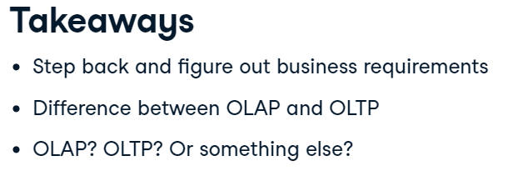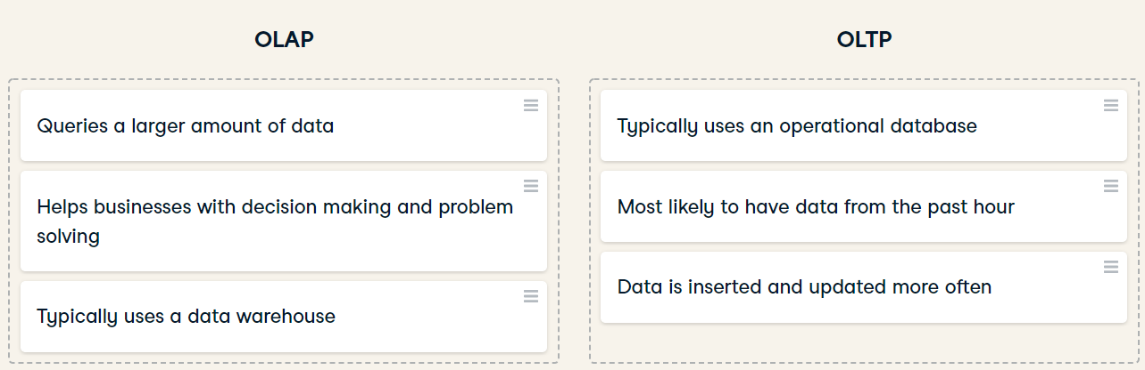

## **Storing data**

Structuring data

Data can be stored in three different levels. The first is structured data, which is usually defined by schemas. Data types and tables are not only defined, but relationships between tables are also defined, using concepts like foreign keys. The second is unstructured data, which is schemaless and data in its rawest form, meaning it's not clean. Most data in the world is unstructured. Examples include media files and raw text. The third is semi-structured data, which does not follow a larger schema, rather it has an ad-hoc self-describing structure. Therefore, it has some structure. This is an inherently vague definition as there can be a lot of variation between structured and unstructured data. Examples include NoSQL, XML, and JSON, which is shown here on the right.

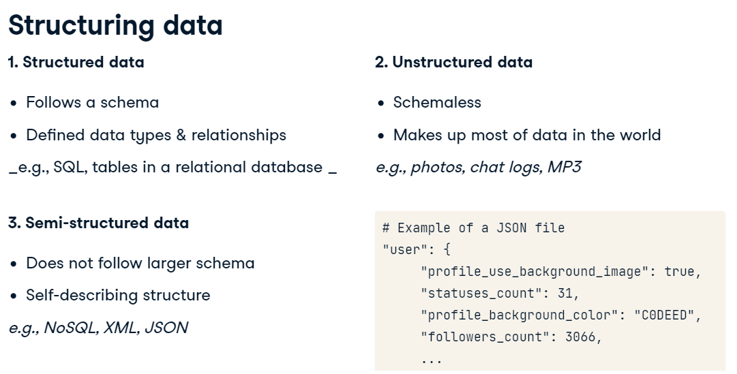Because its clean and organized, structured data is easier to analyze. However, it's not as flexible because it needs to follow a schema, which makes it less scalable. These are trade-offs to consider as you move between structured and unstructured data. 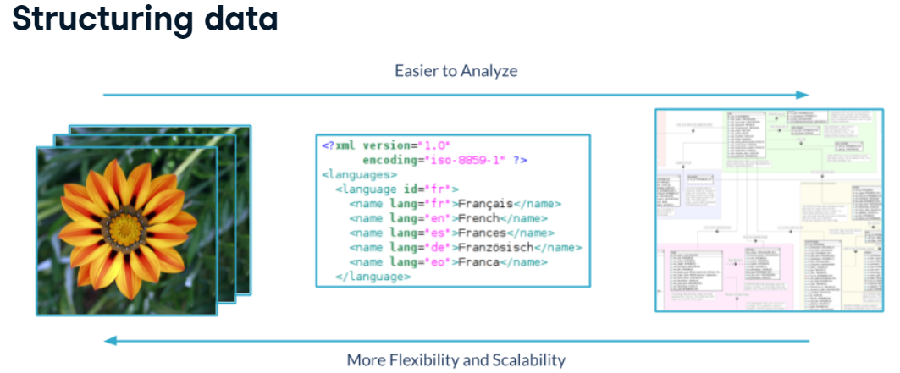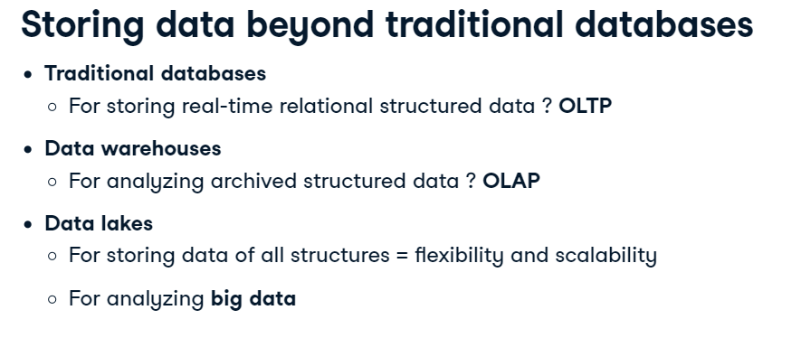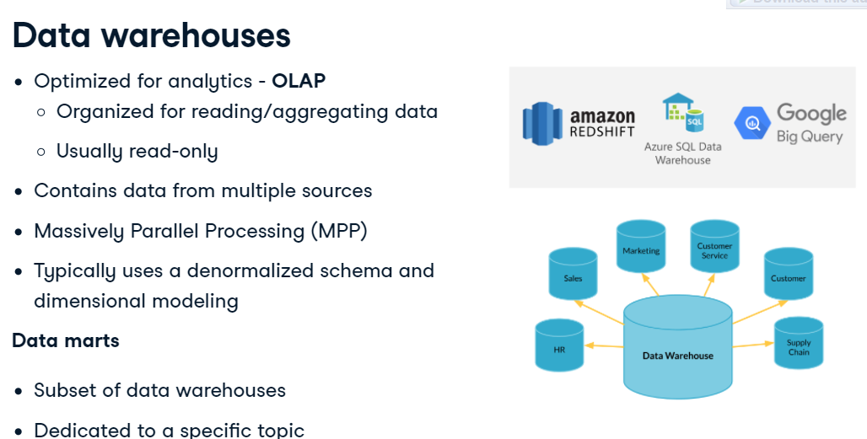

Storing data beyond traditional databases

You should already be familiar with traditional databases. They generally follow relational schemas. Operational databases, which are used for OLTP, are an example of traditional databases. Decades ago, traditional databases used to be enough for data storage. Then as data analytics took off, data warehouses were popularized for OLAP approaches. And, now in the age of big data, we need to analyze and store even more data, which is where the data lake comes in. I use the term "traditional databases" because many people consider data warehouses and lakes to be a type of database.

 Data warehouses

Data warehouses are optimized for read-only analytics. They combine data from multiple sources and use massively parallel processing for faster queries. In their database design, they typically use dimensional modeling and a denormalized schema. We will walk through both of these terms later in the course. Amazon, Google, and Microsoft all offer data warehouse solutions, known as Redshift, Big Query, and Azure SQL Data Warehouse, respectively. A data mart is a subset of a data warehouse dedicated to a specific topic. Data marts allow departments to have easier access to the data that matters to them.

 Data lakes

Technically, traditional databases and warehouses can store unstructured data, but not cost-effectively. Data Lake storage is cheaper because it uses object storage as opposed to the traditional block or file storage. This allows massive amounts of data to be stored effectively of all types, from streaming data to operational databases. Lakes are massive because they store all the data that might be used. Data lakes are often petabytes in size - that's 1,000 terabytes! Unstructured data is the most scalable, which permits this size. Lakes are schema-on-read, meaning the schema is created as data is read. Warehouses and traditional databases are classified as schema-on-write because the schema is predefined. Data lakes have to be organized and cataloged well; otherwise, it becomes an aptly named "data swamp." Data lakes aren't only limited to storage. It's becoming popular to run analytics on data lakes. This is especially true for tasks like deep learning and data discovery, which needs a lot of data that doesn't need to be that "clean." Again, the big three cloud providers all offer a data lake solution.

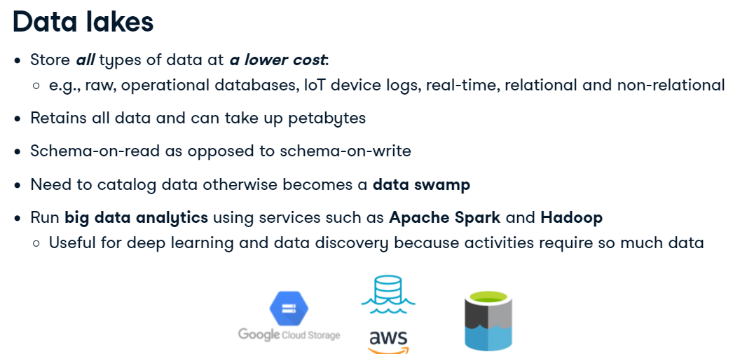Extract, Transform, Load or Extract, Load, Transform

When we think about where to store data, we have to think about how data will get there and in what form. Extract Transform Load and Extract Load Transform are two different approaches for describing data flows. They get into the intricacies of building data pipelines, which we will not get into. ETL is the more traditional approach for warehousing and smaller-scale analytics. But, ELT has become common with big data projects. In ETL, data is transformed before loading into storage - usually to follow the storage's schema, as is the case with warehouses. In ELT, the data is stored in its native form in a storage solution like a data lake. Portions of data are transformed for different purposes, from building a data warehouse to doing deep learning. 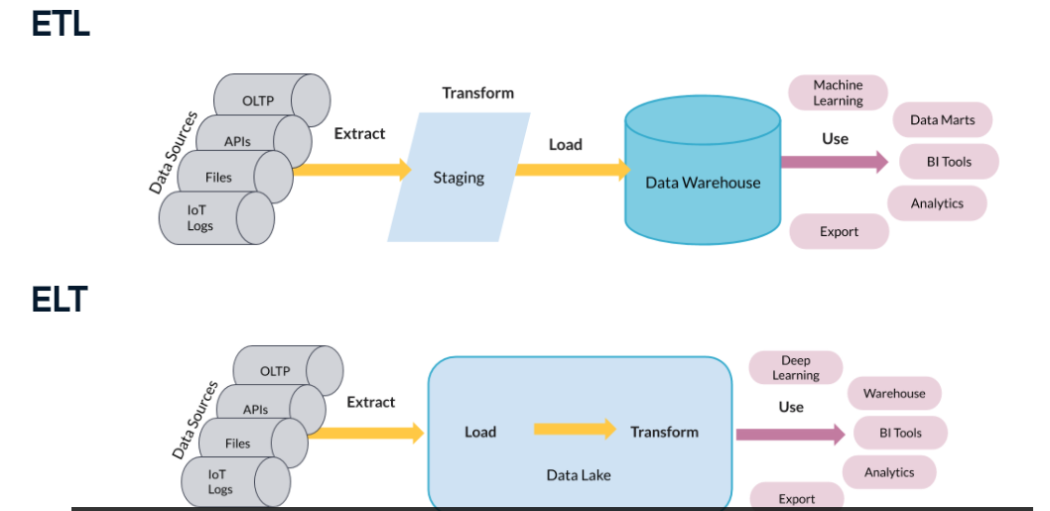

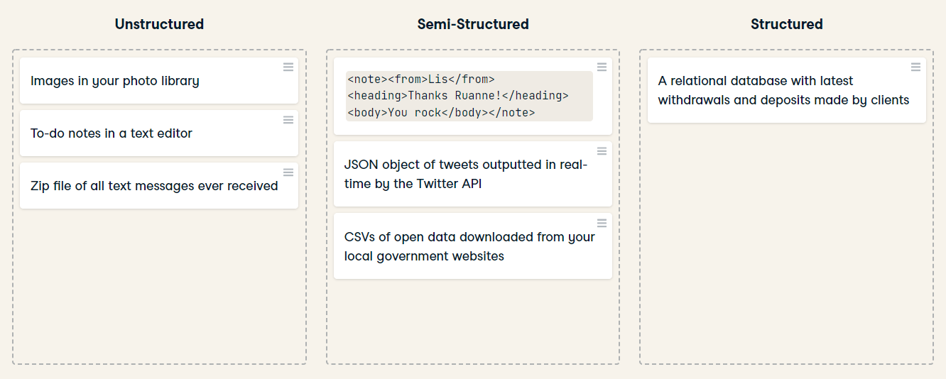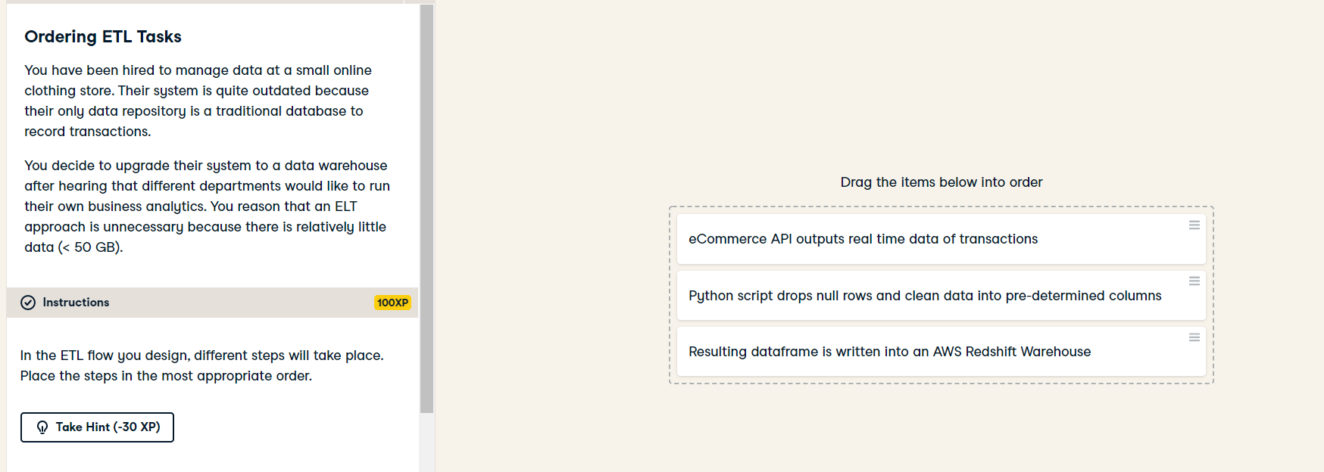

## **Database design**

 What is database design?

Database design determines how data is logically stored. This is crucial because it affects how the database will be queried, whether for reading data or updating data. There are two important concepts to know when it comes to database design: Database models and schemas. Database models are high-level specifications for database structure. The relational model, which is the most popular, is the model used to make relational databases. It defines rows as records and columns as attributes. It calls for rules such as each row having unique keys. There are other models that exist that do not enforce the same rules. A schema is a database's blueprint. In other words, the implementation of the database model. It takes the logical structure more granularly by defining the specific tables, fields, relationships, indexes, and views a database will have. Schemas must be respected when inserting structured data into a relational database.

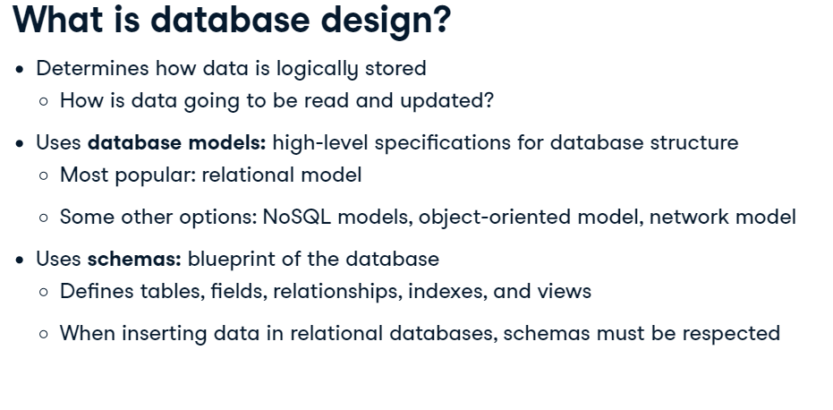 . Data modeling

The first step to database design is data modeling. This is the abstract design phase, where we define a data model for the data to be stored. There are three levels to a data model: A conceptual data model describes what the database contains, such as its entities, relationships, and attributes. A logical data model decides how these entities and relationships map to tables. A physical data model looks at how data will be physically stored at the lowest level of abstraction. These three levels of a data model ensure consistency and provide a plan for implementation and use.

1. 1 https://en.wikipedia.org/wiki/Data_model

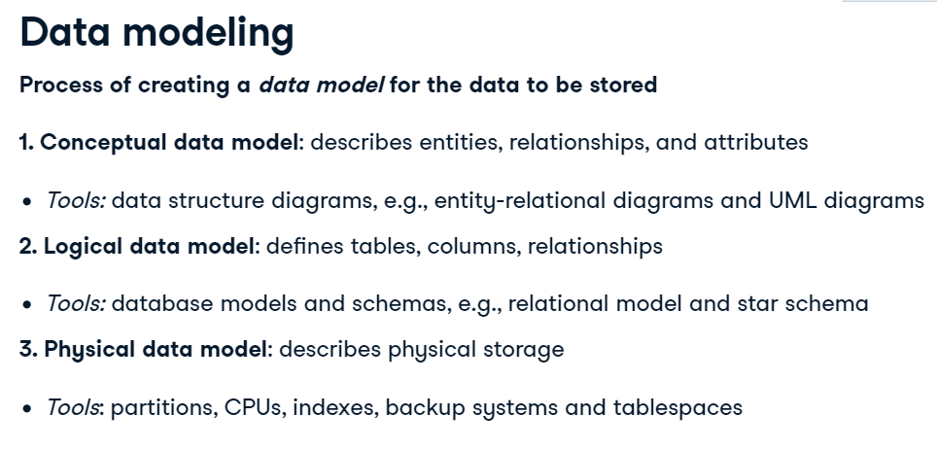

An example

Here is a simplified example of where we want to store songs. In this case, the entities are songs, albums, and artists with various pink attributes. Their relationships are denoted by blue rhombuses. Here we have a conceptual idea of the data we want to store. Here is a corresponding schema using the relational model. The fastest way to create a schema is to translate the entities into tables. But just because it's the easiest, doesn't mean it's the best. Let's look at some other ways this ER diagram could be converted.

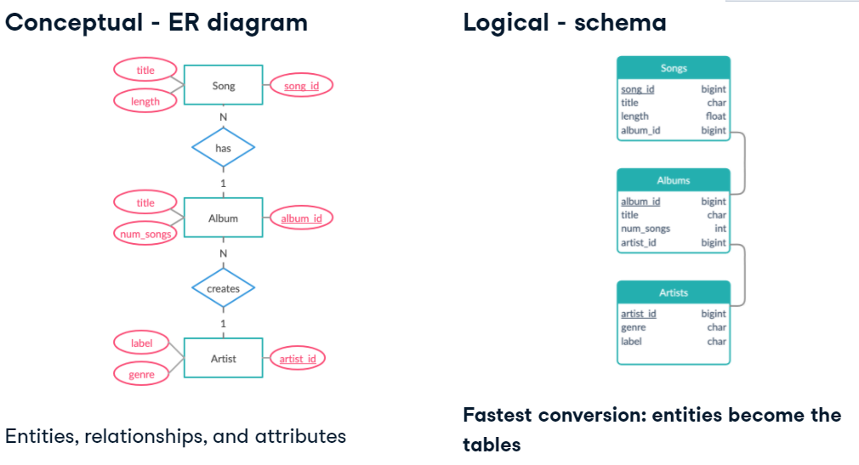 Other database design options

For example, you could opt to have one table because you don't want to have to run so many joins to get song information. Or, you could add tables for genre and label. Many songs share these attributes, and having one place for them helps with data integrity. The biggest difference here is how the tables are determined. There are different pros and cons to these three examples I've shown. The next chapter on normalization and denormalization will expand on this. 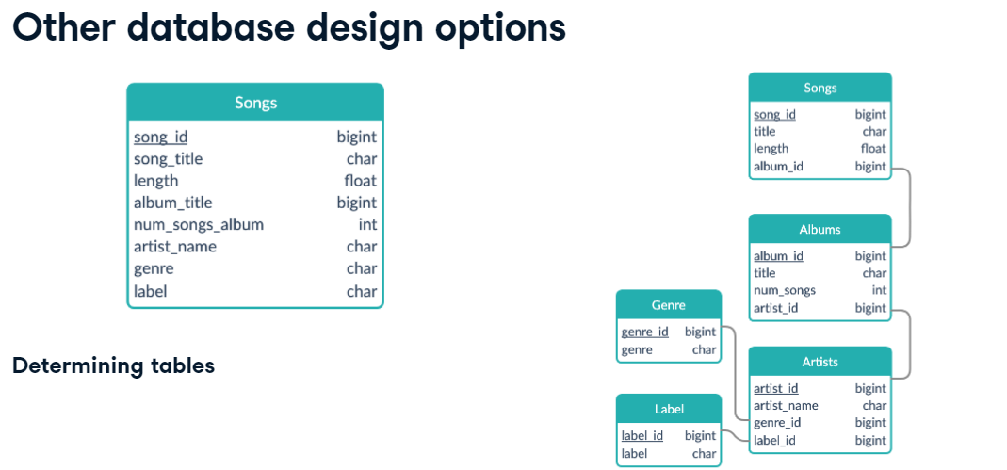

 Beyond the relational model

From the prerequisites, you should be familiar with the relational model. Dimensional modeling is an adaptation of the relational model specifically for data warehouses. It's optimized for OLAP type of queries that aim to analyze rather than update. To do this, it uses the star schema. In the next chapter, we'll delve into that more. As we will see in the next slide, the schema of a dimensional model tends to be easy to interpret and extend. This is a big plus for analysts working on the warehouse. 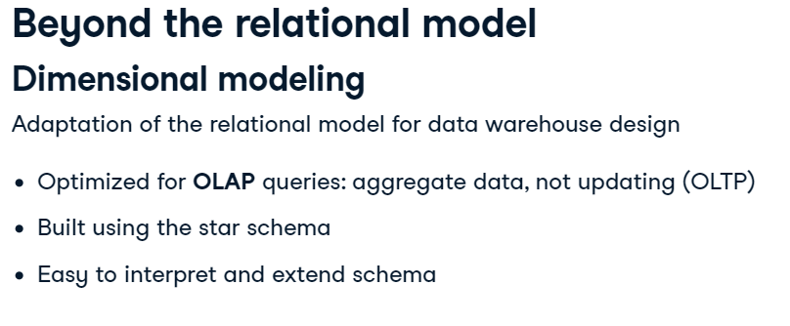 Elements of dimensional modeling

Dimensional models are made up of two types of tables: fact and dimension tables. What the fact table holds is decided by the business use-case. It contains records of a key metric, and this metric changes often. Fact tables also hold foreign keys to dimension tables. Dimension tables hold descriptions of specific attributes and these do not change as often. So what does that mean? Let's bring back our example, where we're analyzing songs. The turquoise table is a fact table called songs. It contains foreign keys to purple dimension tables. These dimension tables expand on the attributes of a fact table, such as the album it is in and the artist who made it. The records in fact tables often change as new songs get inserted. Albums, labels, artists, and genres will be shared by more than one song - hence records in dimension tables won't change as much. Summing it up, to decide the fact table in a dimensional model, consider what is being analyzed and how often entities change.

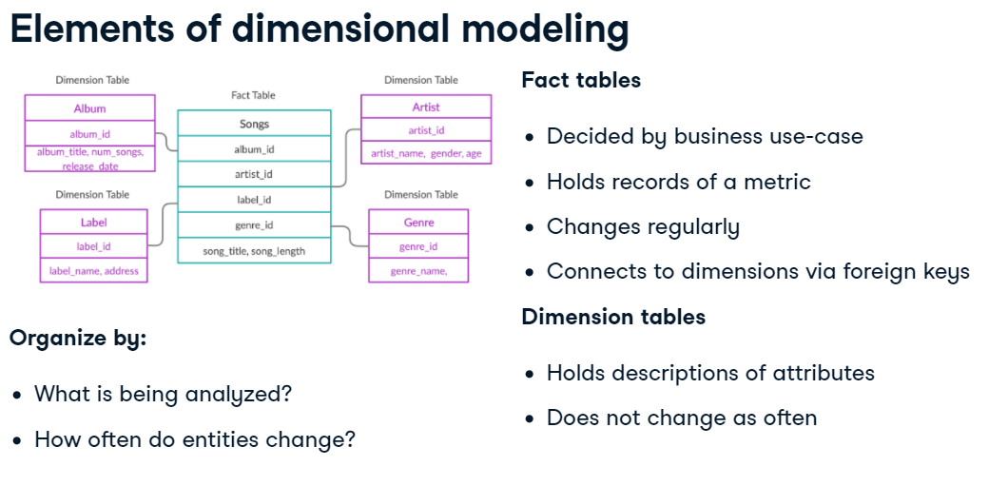 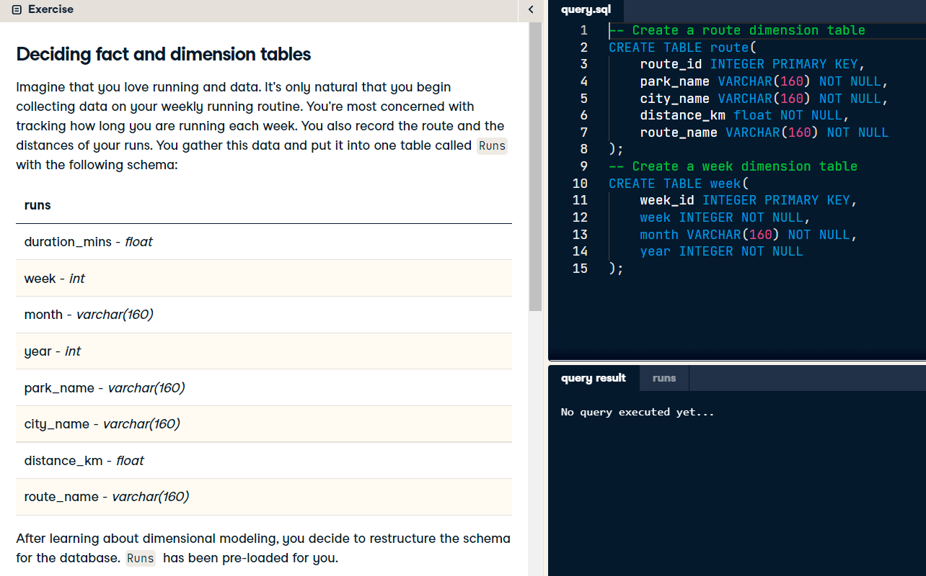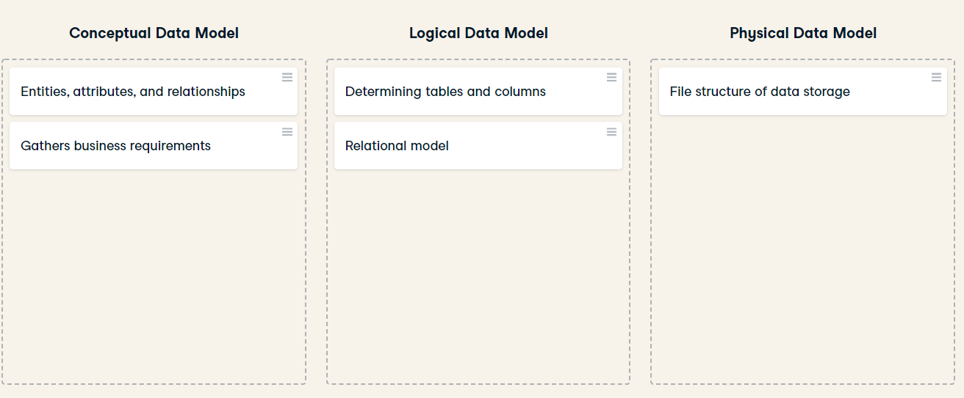

## Dimensional modelling

to understand dimensional modelling let’s take an example, a customer is going to purchase an item from a retail shop. Let’s analyze this usecase and see what kind of information we can have from this process,

This process we can call it in general a business process or an event has two sides:measurse side and event details side

Measure side like, order value : what is the amount paid in this order

VAT value : what is the amount of taxes added to this value

event details side like, product name , category of each product , who is the employes interacted with this customer

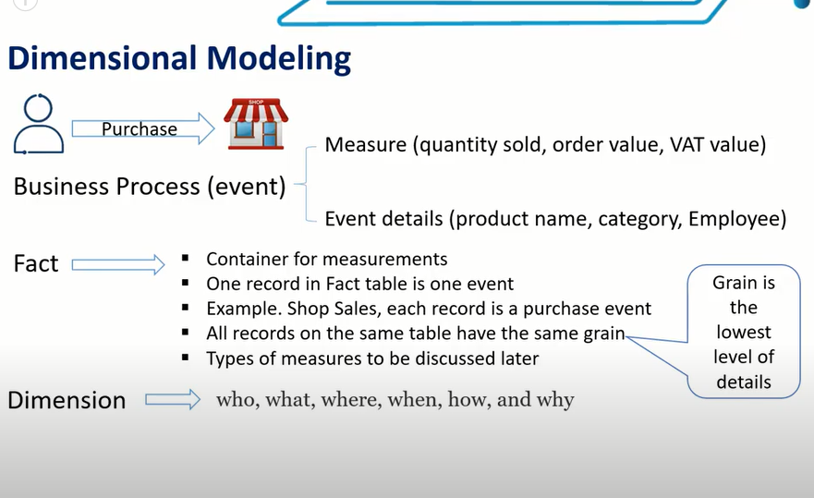

Who is the customer , so we will have a customer dimension.

Who is the employee , so we will have an employee dimension.

What is the product customer purchased in this order(event) , so we will have product dimension.

(where)From which shop customer purchased this order .

(When) what is the date and time customer purchased this order.

(how) the customer paid for this order , so we will have a payment-method dimension.

(why) did customer came in a response to a marketing compaign or did he came by visiting our website or from a social media advertising and so on , so we will have a channel dimension.

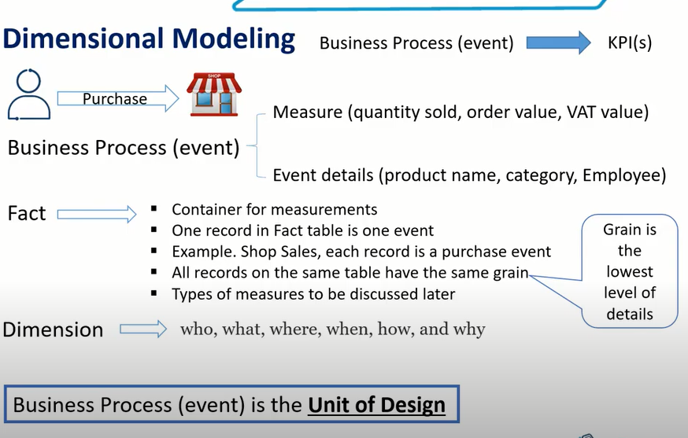the outcome of business process(event) is kpi

In dimensional modelling we start by checking all available business processes(EVENTS) , we don’t check datasets available.so business process is the unit of design of dimrnsional modelling 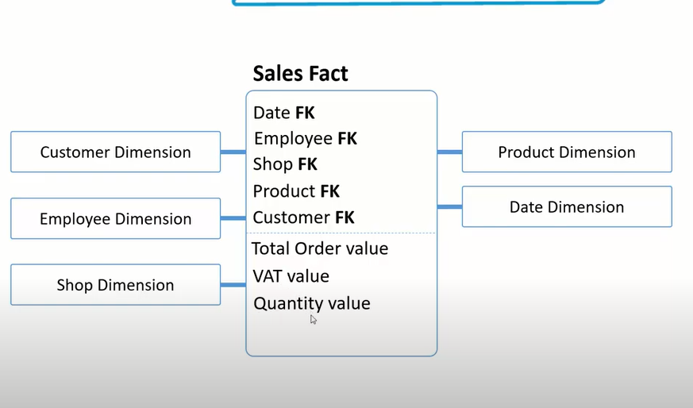

## Dimension keys

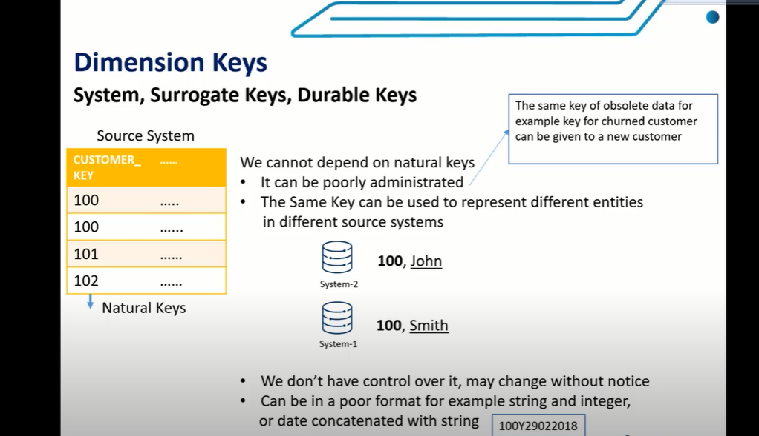source system key(natural key) can’t be depended on it at all as a primary key

Point no.5 : this key is a natural key which is in a very poor format 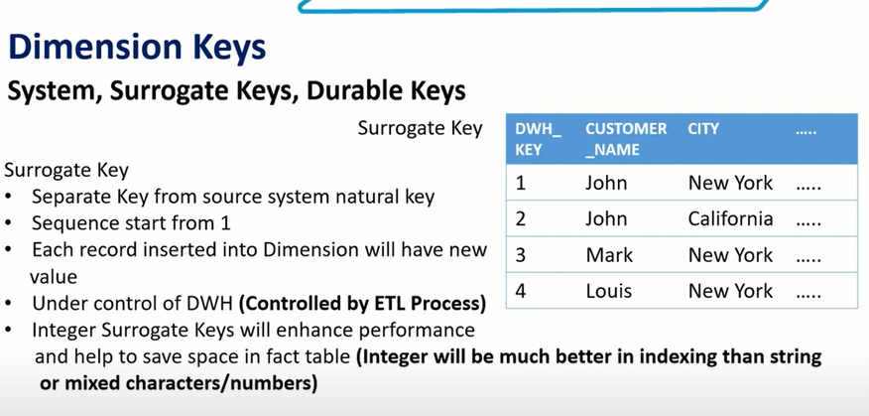

As discussed it’s not recommended at all to use source or natural key as a primary key for dimension tables , so **surrogate key** comes to solve this problem , which are auto generated incremental sequence which help us to uniquely identify each record

[Generating Surrogate Keys With SSIS | Sam Vanga (wordpress.com)](https://svangasql.wordpress.com/2012/06/24/surrogate-key-ssis-typ1-type2-scd/#:~:text=Generating%20Surrogate%20Keys%20With%20SSIS%20June%2024%2C%202012,to%20join%20a%20dimension%20to%20a%20fact%20table.)

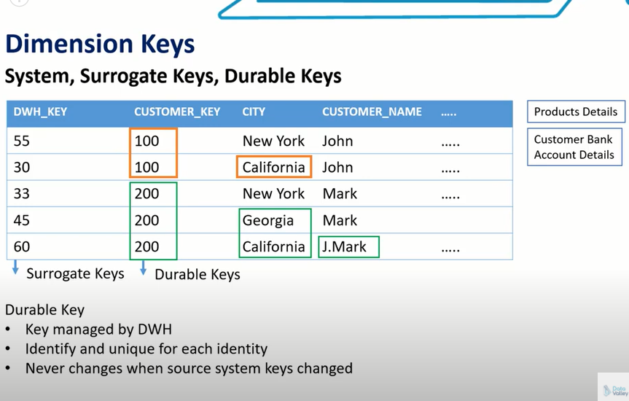

We need durable keys when we need a fixed and unique fpr an entity which it could be a customer or a product or a service that will never change whenever details of this entity changes

مثلا عندي عميل في البنك ليه كريدت كارد وليه key عندي نفترض مثلا ان الكارد بتاعته ضاعت مينفعش اسجله ب key مختلف

Here comes the role of durable key , I use it in cases like product details or customer bank account derails.

## Dimension types

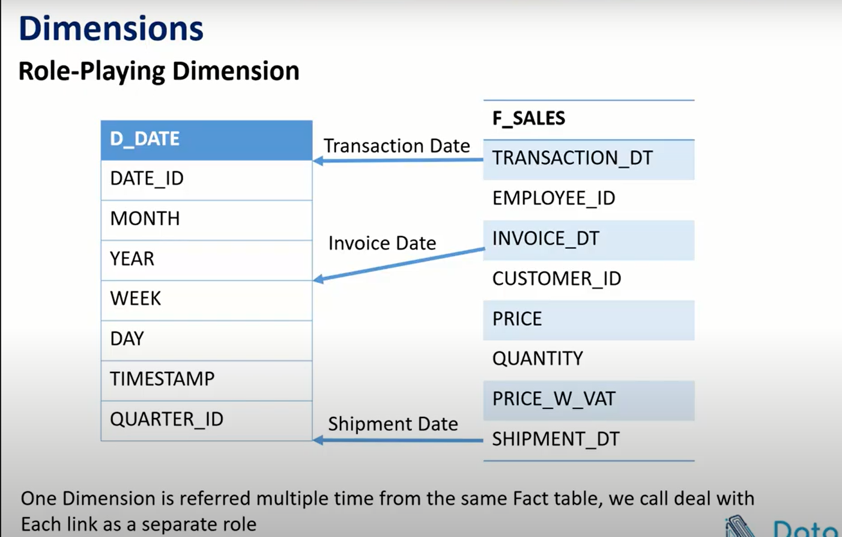IN THIS case when create views or we can create separate tables that depend on the same dimension and give them different names

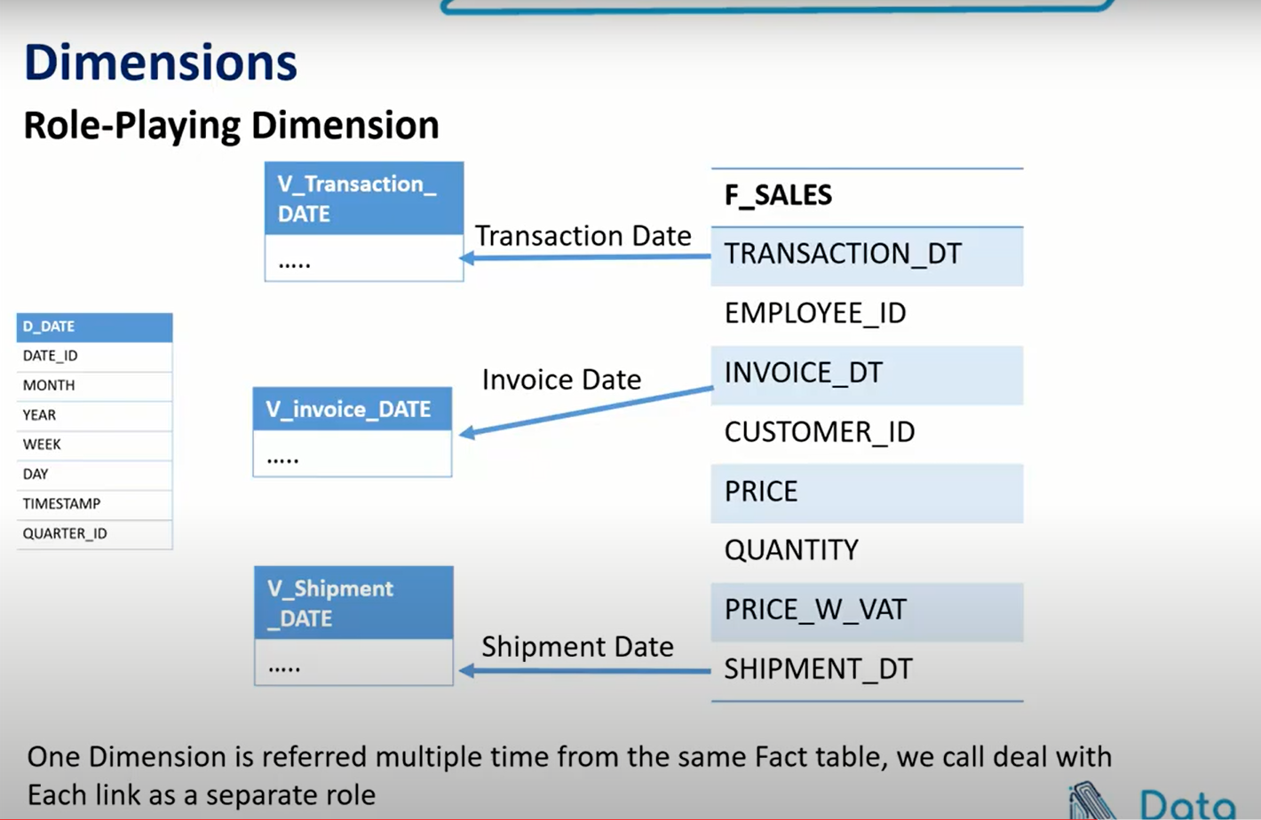

conformed dimension is very critical because it will impact a lot of kpis across many departments(data marts) of the organization.

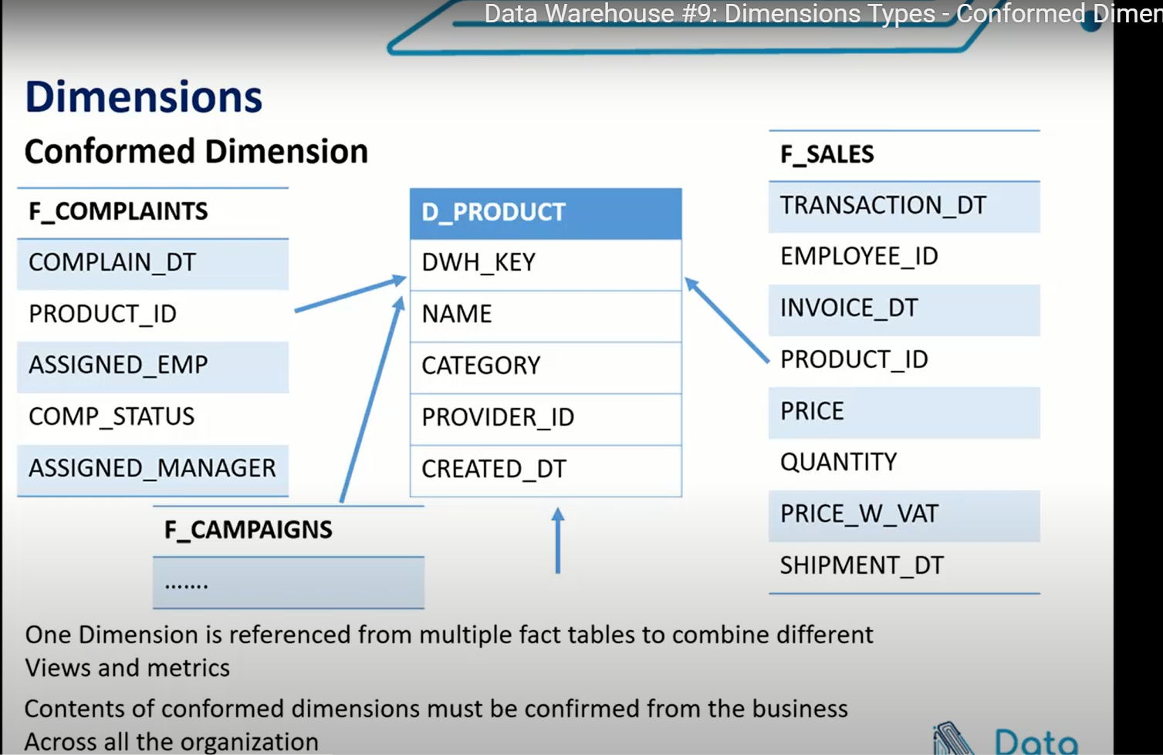 here we have four columns , each column represents a certain status for the order (confirmed-received-shipped-delivered).

In this case, as we know all possible combinations of the four flags we can take all of these flags and put it in a separate dimension and we call it a **junk dimension** and each possible combination we will give it a unique ID

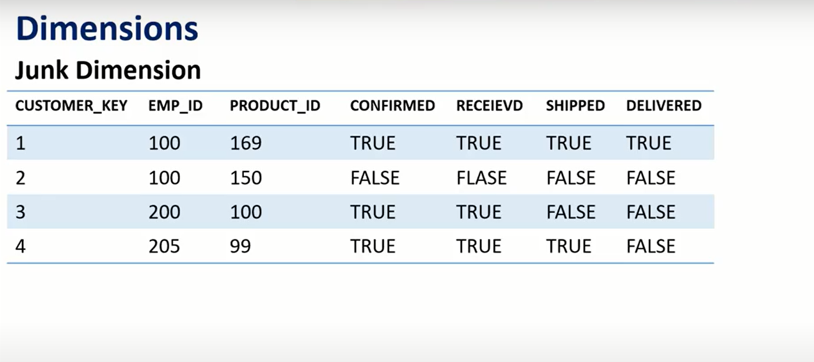 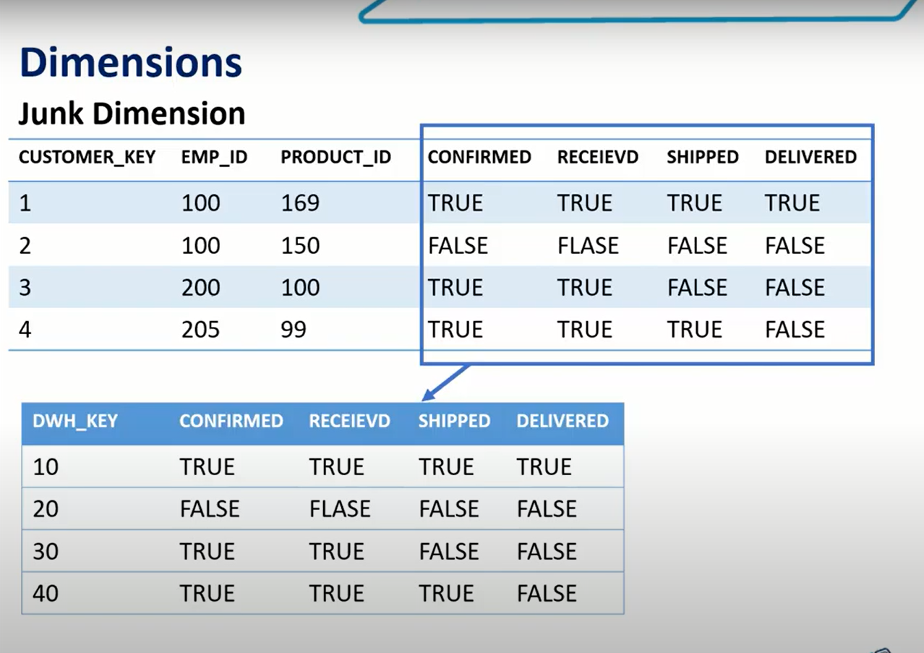and in fact table we will replace them with the new column 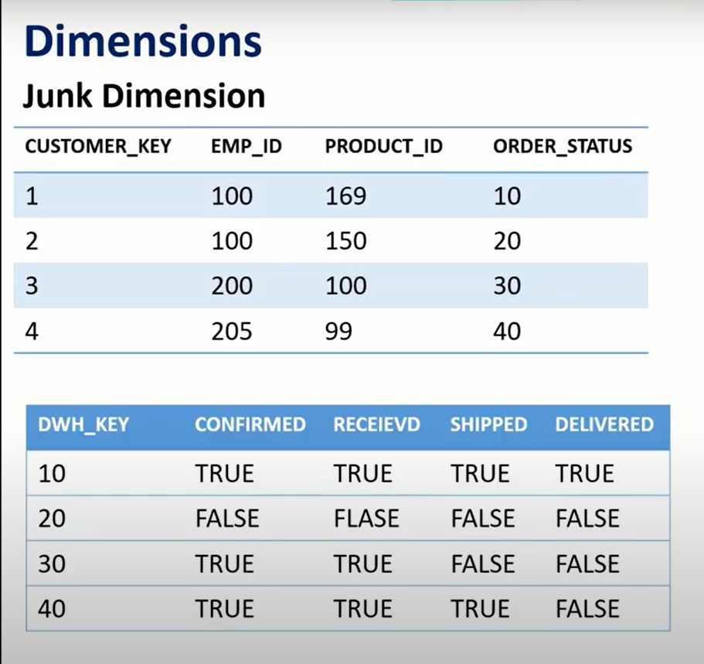we do that to save storage and enhance performance 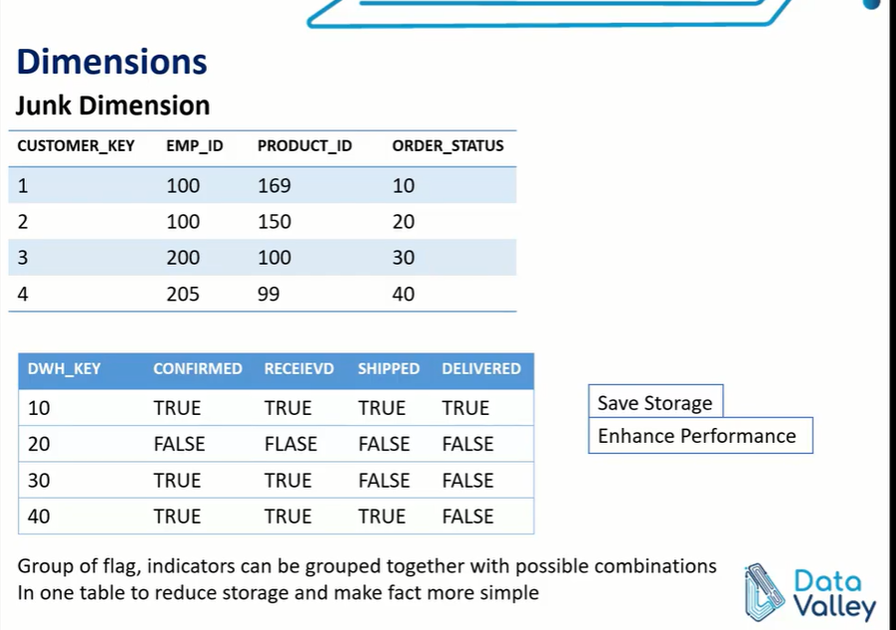

One of the main properties of data warehuose is that data warehouse should keep history so we can do our history analysis and so we can generate kpis based on historical values

Type 0 : no history :whenever data changes in source system we will never change data in data warehouse , in some dimensions (it maybe a reference dimensions , just a look up for some values) so we don’t need actually to track history **but it’s very very rare and special cases**

## Slowly changing dimension types

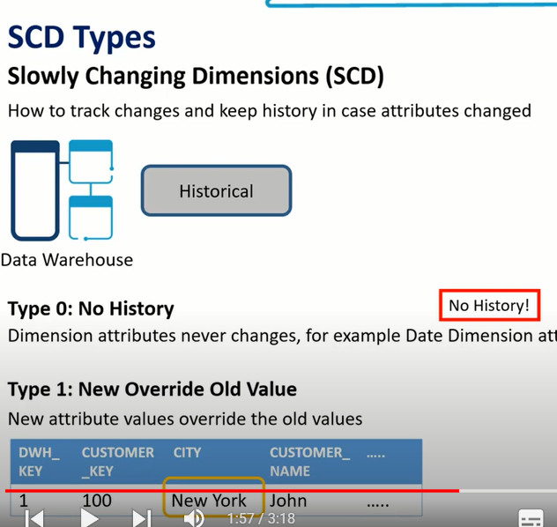

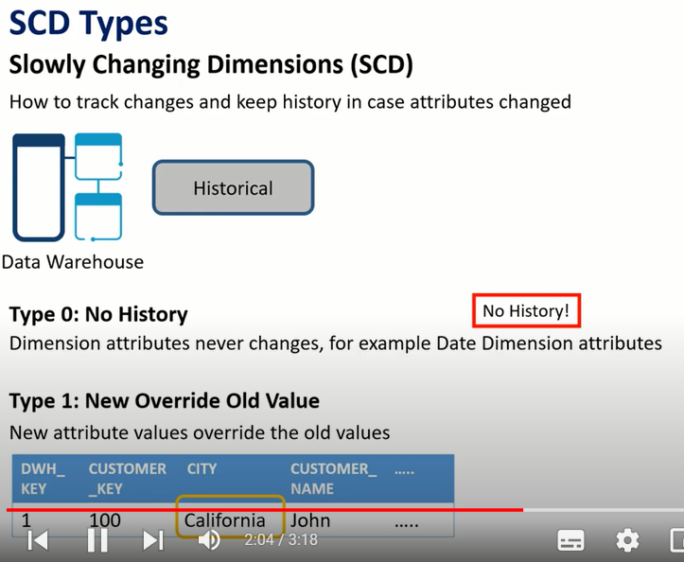 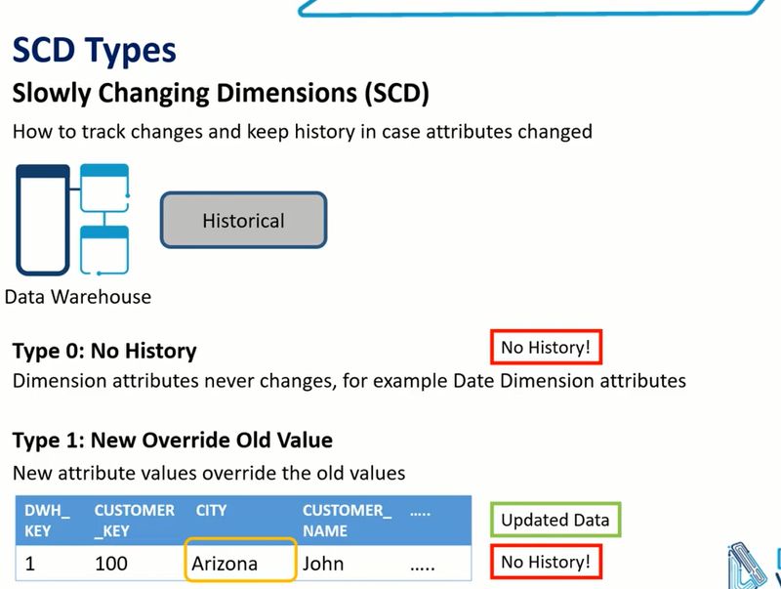

In type 2 we track every single in source data and we will reflect it in our dimension data ,We need a flag or some sort of mechanism to differentiate from historical and latest data , we have two ways to do this : either we do it with **dates** to indicate the valid range of date for each record, or we can add a **flag** (we can do both)

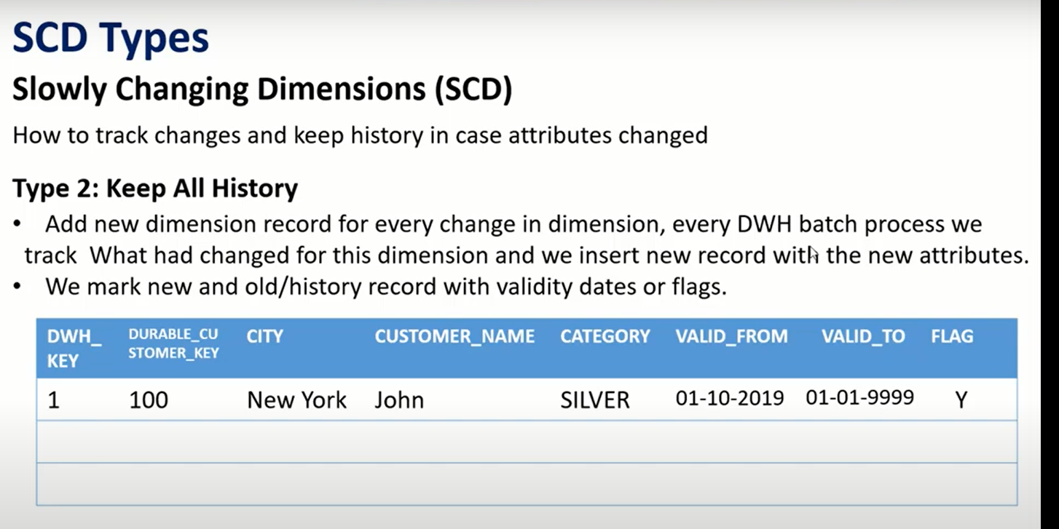to indicate that this is the latest record we should have a default value , like value in valid-to column 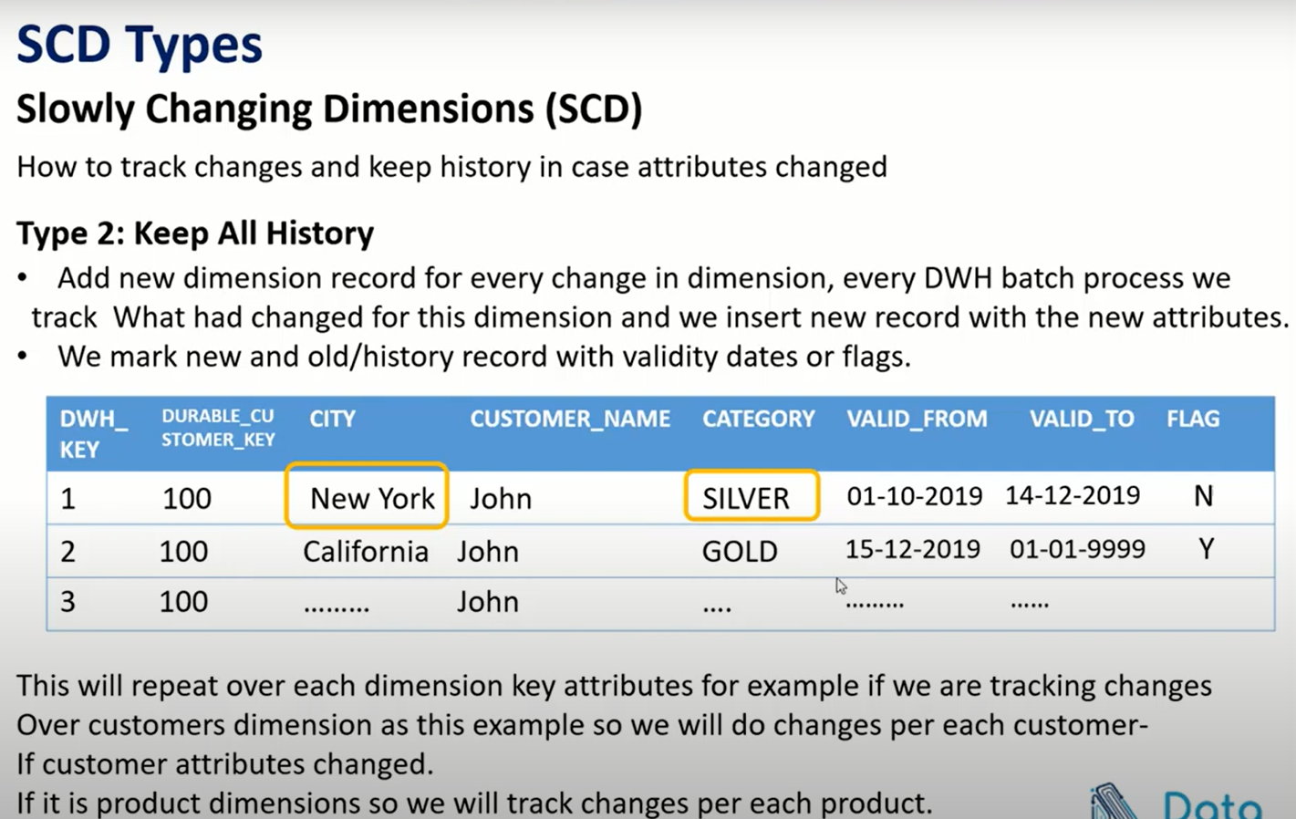

As you can see , durable key didn’t change any time you changed records

Disadvantge: we increase table size

Type 3 : we keep only the previous value

the good point that you have access directly to the previous value as you don’t need to query on a specific condition contrast to type 2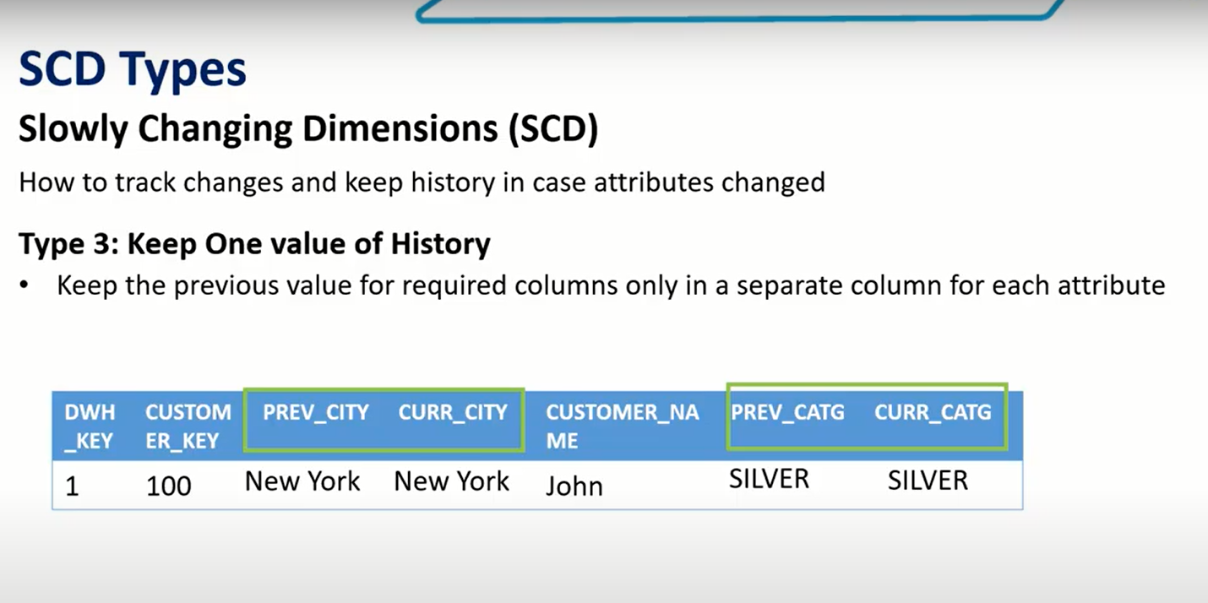if there wasn’t any previous value then we will put the same data 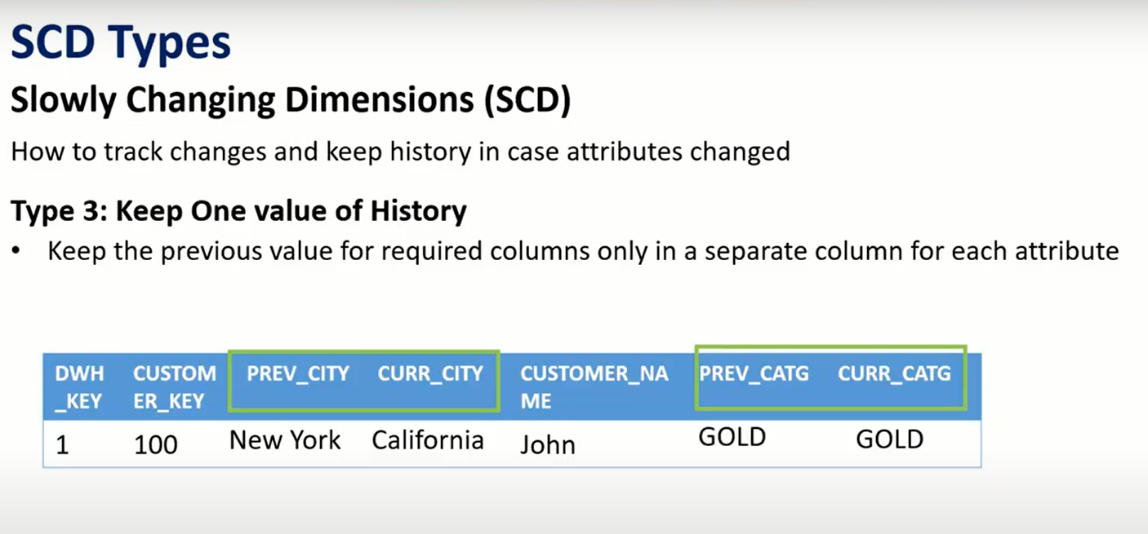

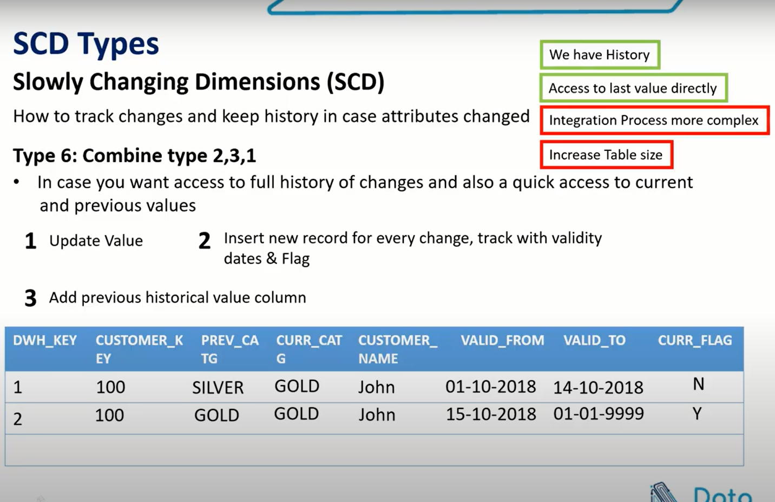

## Fact table

Let’s talk about fact table : depends on type of fact table the record is one event or set of events,if customer purchases 5 items then every item(which is the lowest level of details in the event or process) will be put in a different record cause it’s the grain of the purchase process, and around this fact table grain we build all the required dimensions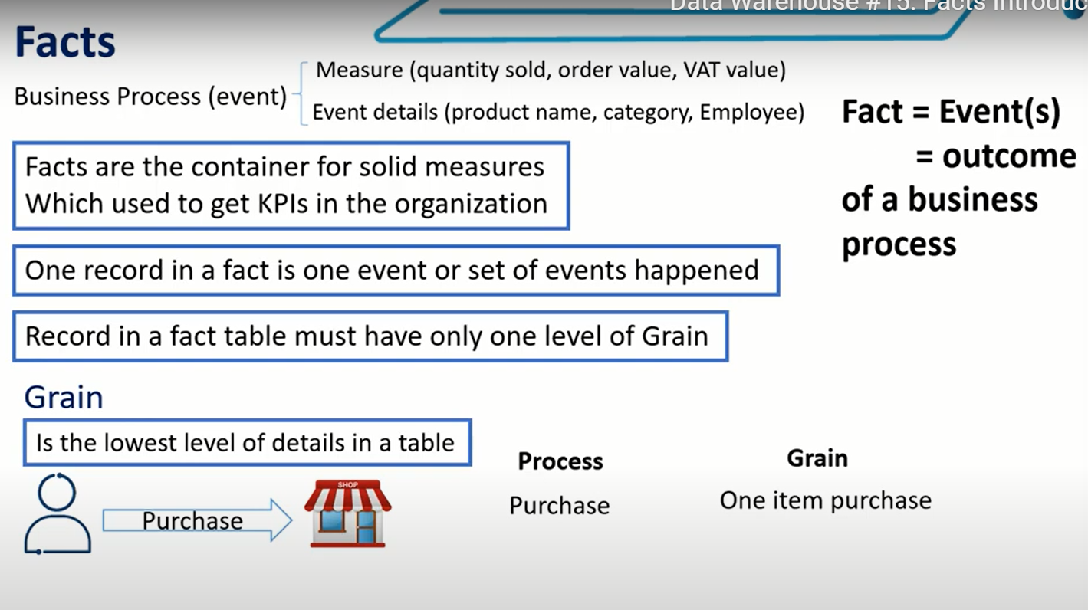

In the same fact table there can’t be more than one grain , for example either purchase grain or complaint grain.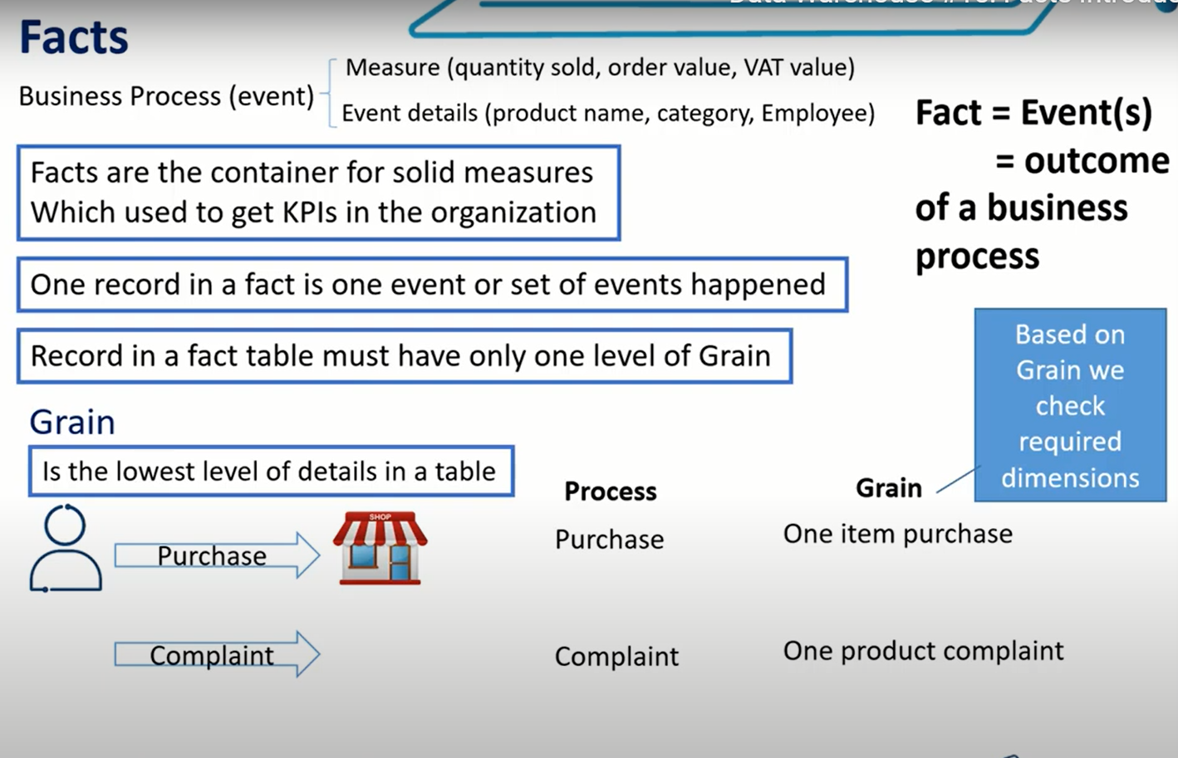so we should have one separate fact table for complaints operations and one separate fact table for purchase operations , and we do that to separate kpis

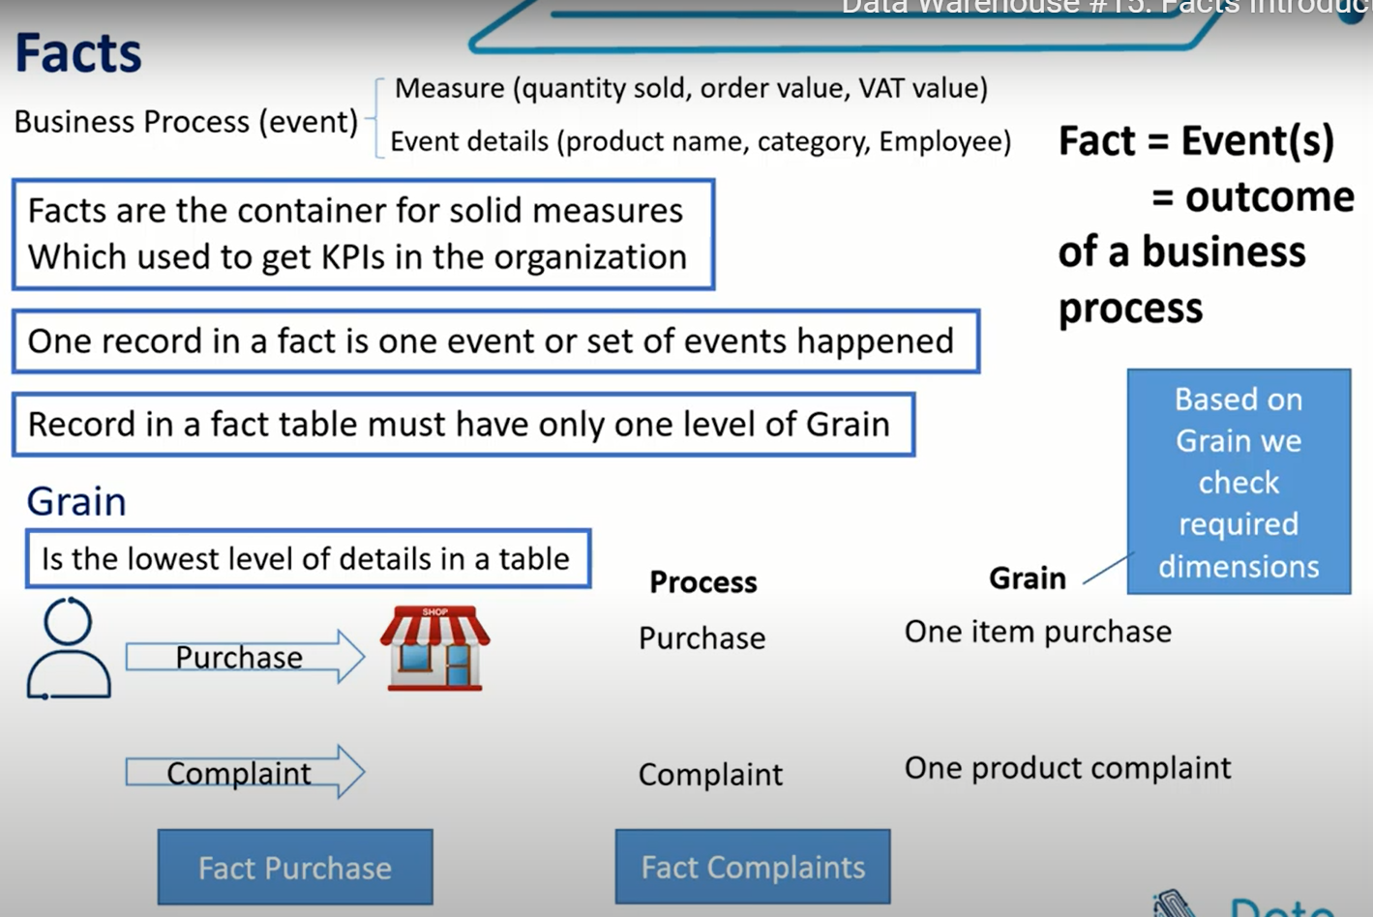

**Types of fact table** : transactional facts 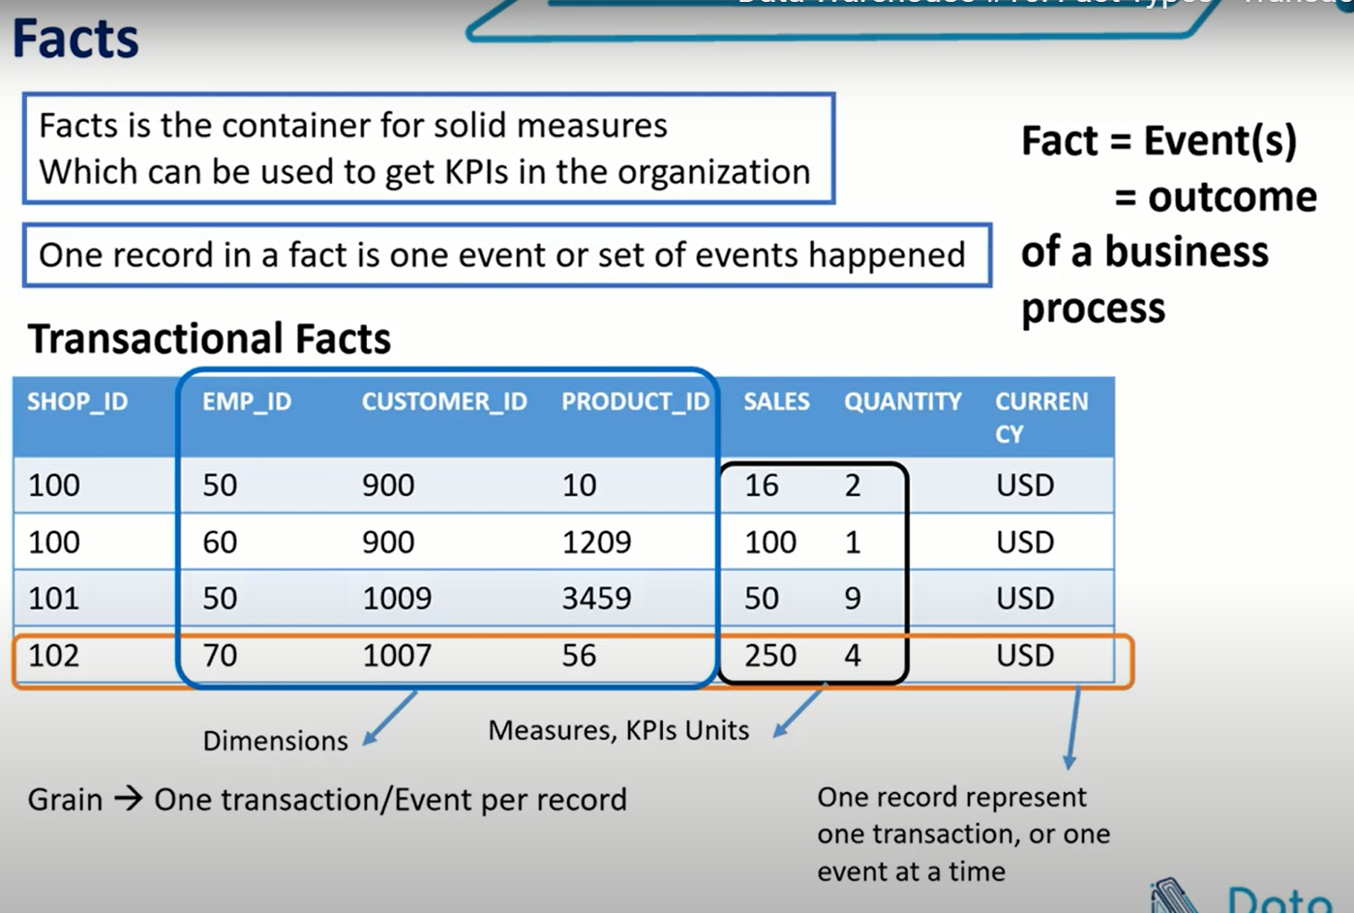

**Types of fact table** :periodic snapshot facts : we aggregate set of measures over certain period of time 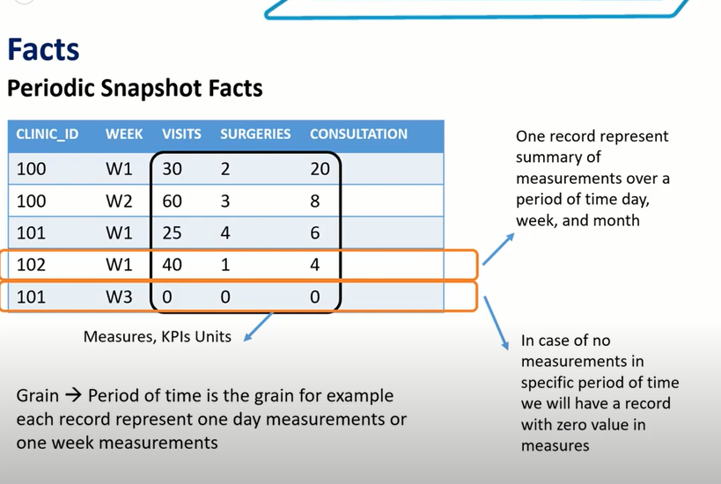

**Types of fact table** :accumulating snapshot facts : used when you want to track process end to end and the monitor is a change of the process

In the same record we update values depending on status 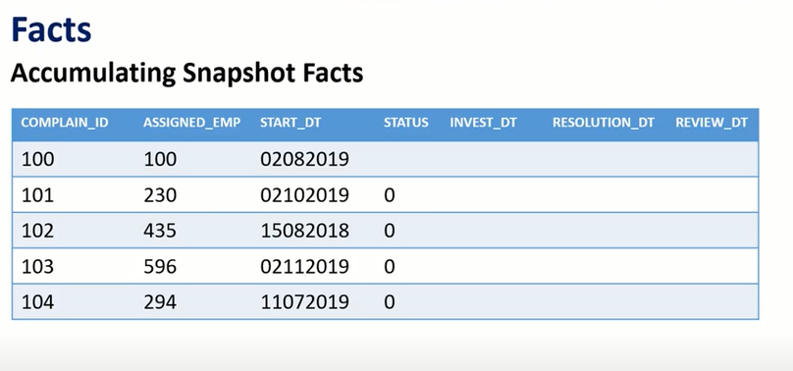 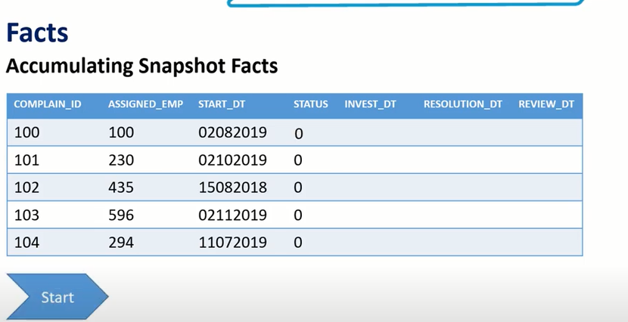 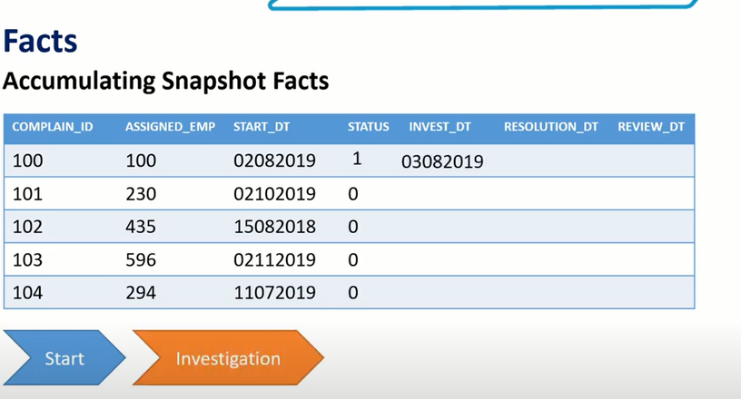 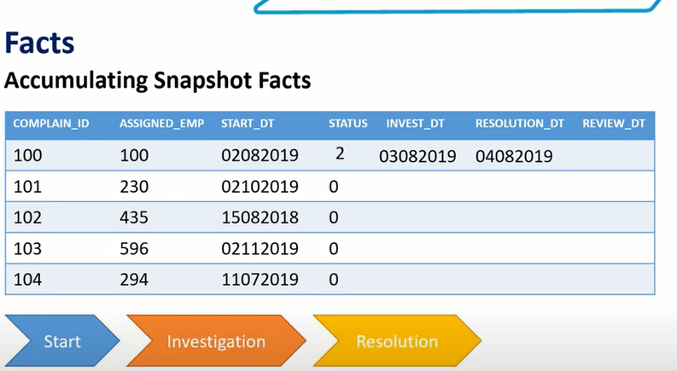 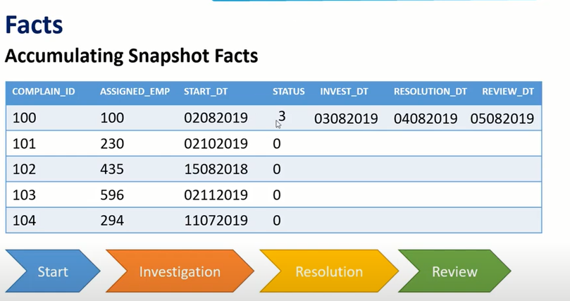 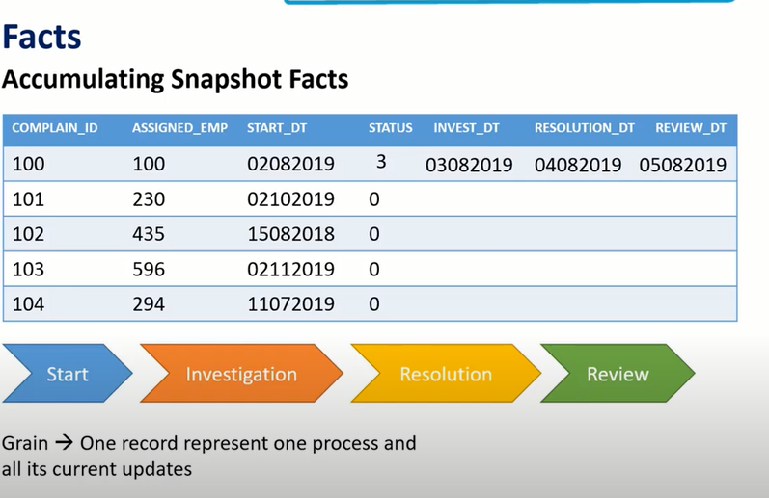

**Types of fact table** :factless fact table : it’s like a registery (there is no measures) , an example for it emp attendence ,,this type is not common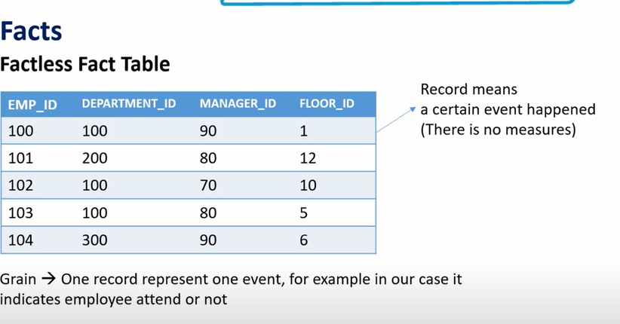

We can have a transactional fact to record order measures and dimensions , if one of decision makers needs to see a weekly summary for our orders so we can design a periodic snap shot fact to read data from transactional fact table and group it over a week timeline, and let’s say we want to analyze order status starting from order place date to order confimation date till shipment date

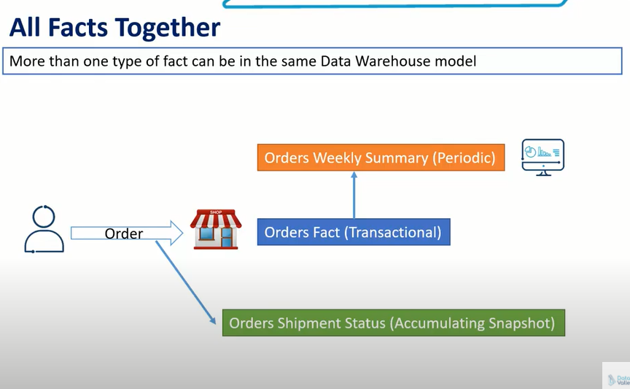

Handle Null Values : in case you have dimension foreign key with null value you should replace it with a default value

For example , promo id indicates if the purchase operation was using a promo code (a package code ) or not

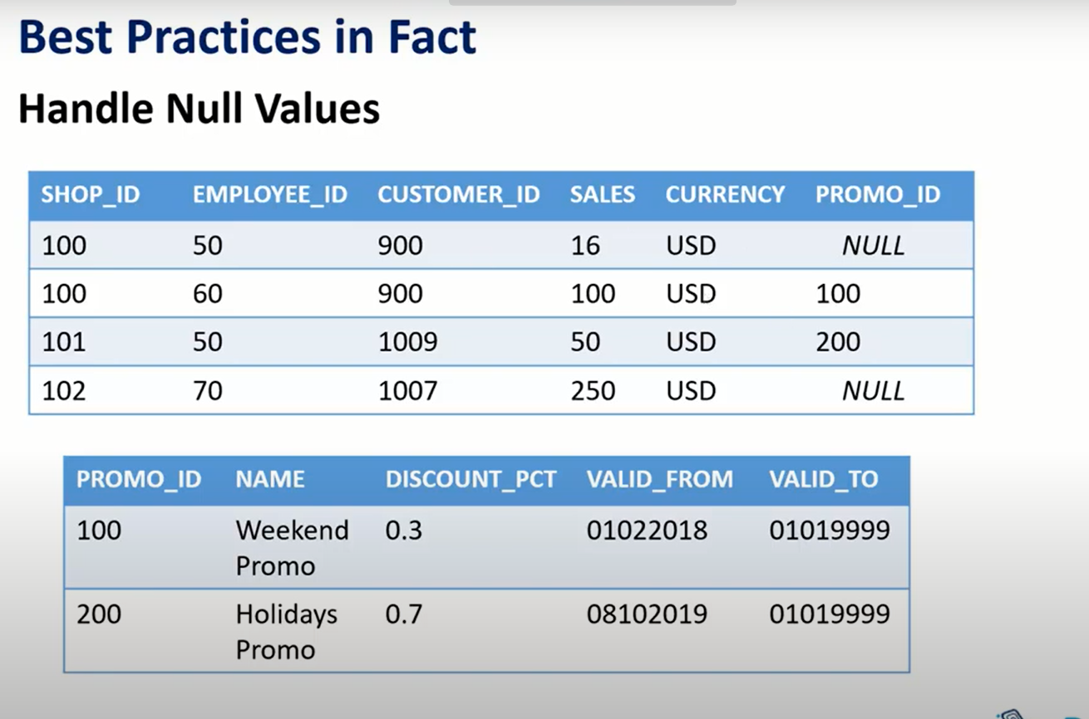let’s say we are going to generate a report to show us revenue distributed by promo code 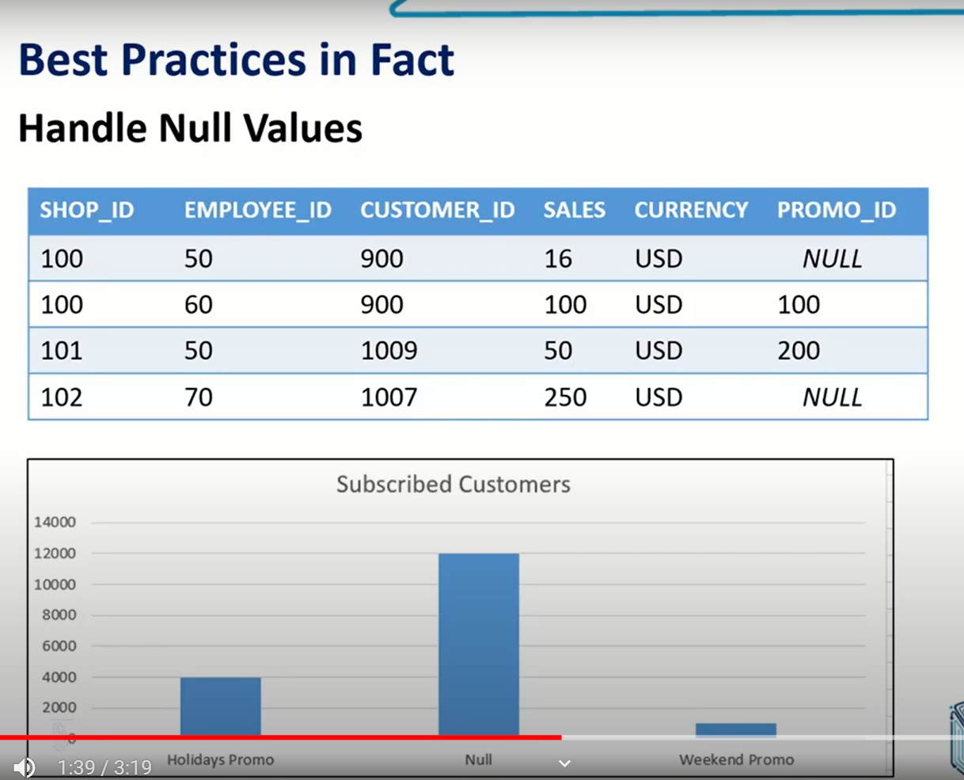when you deliver such report to a stakeholder he doesn’t understand what null denotes for because null value is a technical term and when you deliver a report to a stakeholder you must assurse that all terms are business terms

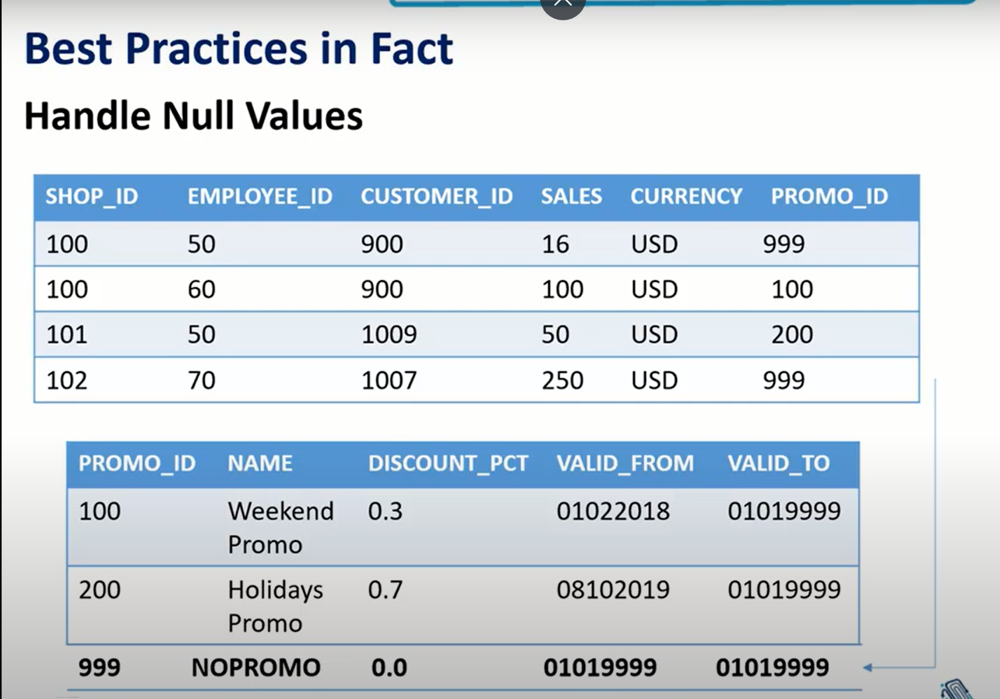

**Types of measures :**

1. **Semi additive : I can aggregate it but I can’t sum it**
2. **Non additive : like percentage**

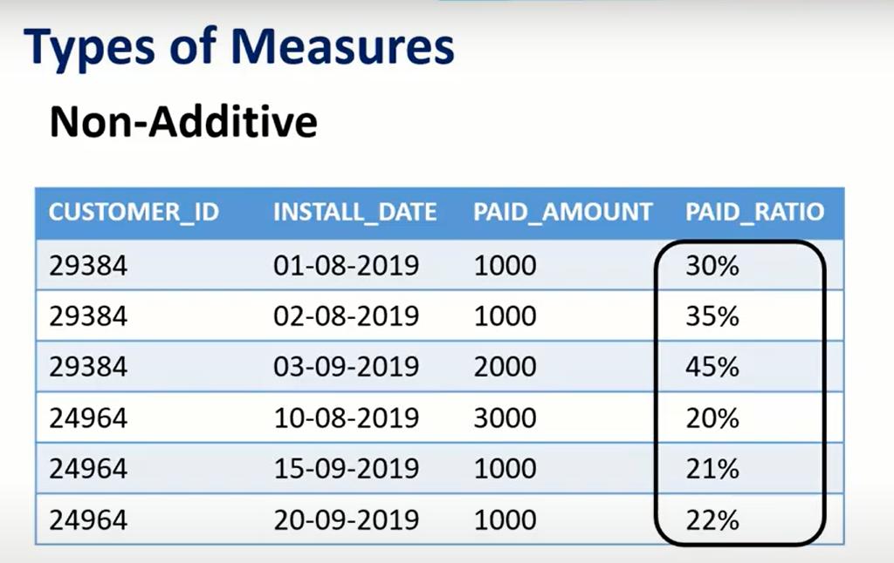one solution for this measure is totake out calculations and insert it as columns so you can do your aggregation 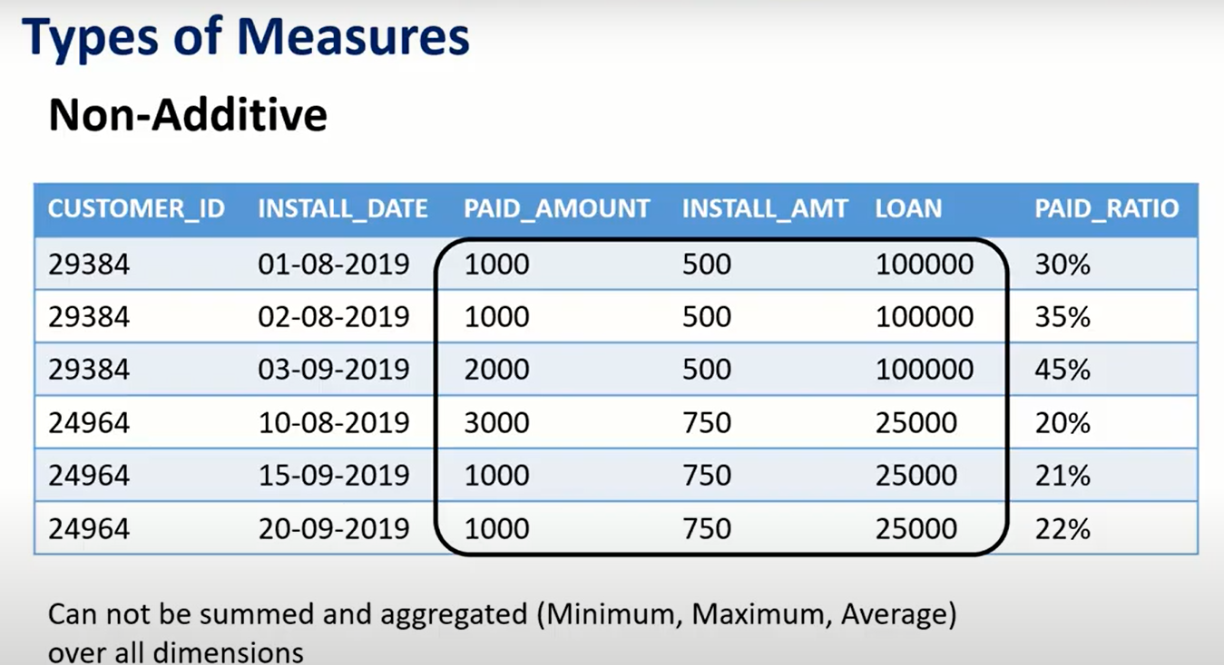

## **Star and snowflake schema**

[What is Dimensional Modeling in Data Warehouse? Learn Types (guru99.com)](https://www.guru99.com/dimensional-model-data-warehouse.html#steps-of-dimensional-modelling)

Star schema

The star schema is the simplest form of the dimensional model. Some use the terms "star schema" and "dimensional model" interchangeably. Remember that the star schema is made up of two tables: fact and dimension tables. Fact tables hold records of metrics that are described further by dimension tables. Throughout this chapter, we are going to use another bookstore example. However, this time, you work for a company that sells books in bulk to bookstores across the US and Canada. You have a database to keep track of book sales. Let's take a look at the star schema for this database.

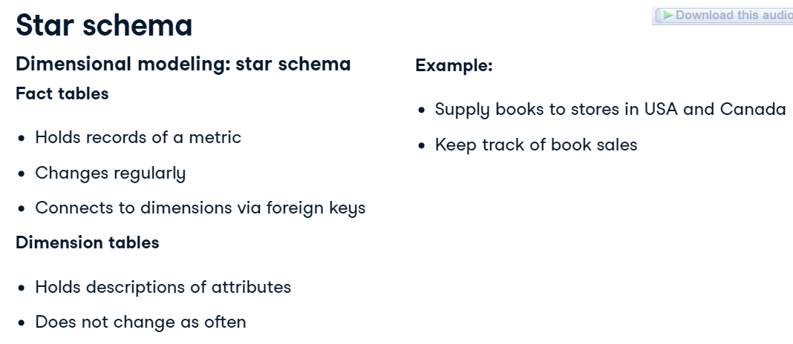 Star schema example

Excluding primary and foreign keys, the fact table holds the sales amount and quantity of books. It's connected to dimension tables with details on the books sold, the time the sale took place, and the store buying the books. You may notice the lines connecting these tables have a special pattern. These lines represent a one-to-many relationship. For example, a store can be part of many book sales, but one sale can only belong to one store. The star schema got its name because it tends to look like a star with its different extension points.

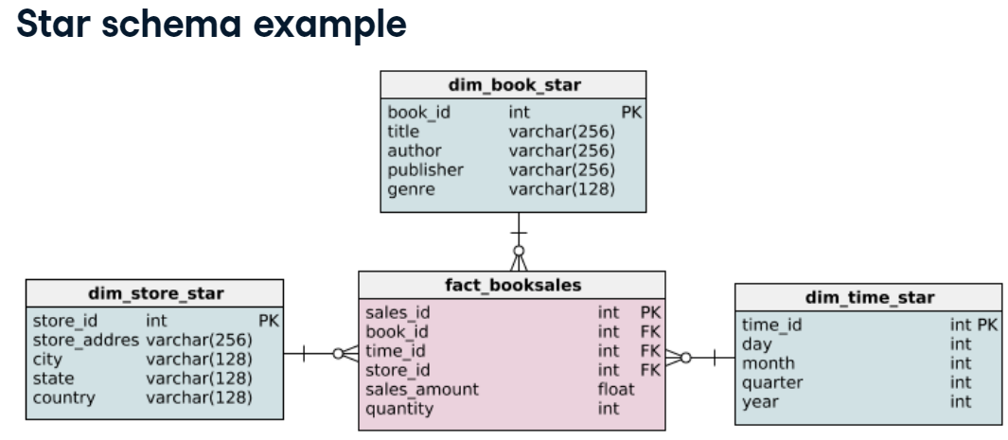

* **Most of out dimension tables probably shouldn’t be too large ,,,, then the role of snow flake schema came.**

Snowflake schema (an extension)

Now that we have a good grasp of the star schema, let's look at the snowflake schema. The snowflake schema is an extension of the star schema. Off the bat, we see that it has more tables. You may not be able to see all the details in this slide, but don't worry it will be broken down in later slides. The information contained in this schema is the same as the star schema. In fact, the fact table is the same, but the way the dimension tables are structured is different. We see that they extend more, hence it's namesake.

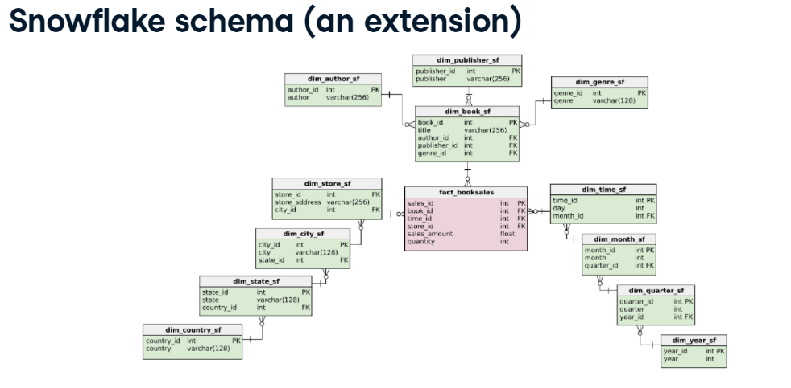 Same fact table, different dimensions

The star schema extends one dimension, while the snowflake schema extends over more than one dimension. This is because the dimension tables are normalized.

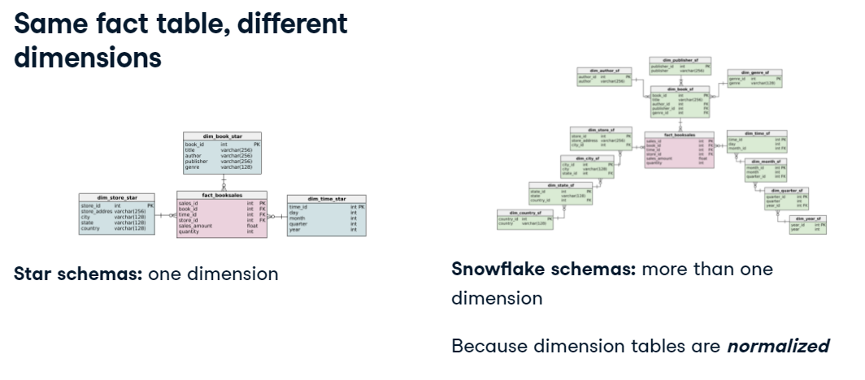 What is normalization?

So what is normalization? Normalization is a technique that divides tables into smaller tables and connects them via relationships.

The goal is to reduce redundancy and increase data integrity. So how does this happen? There are several forms of normalization, which we'll delve into later. But the basic idea is to identify repeating groups of data and create new tables for them. Let's go back to our example and to see how these tables were normalized. 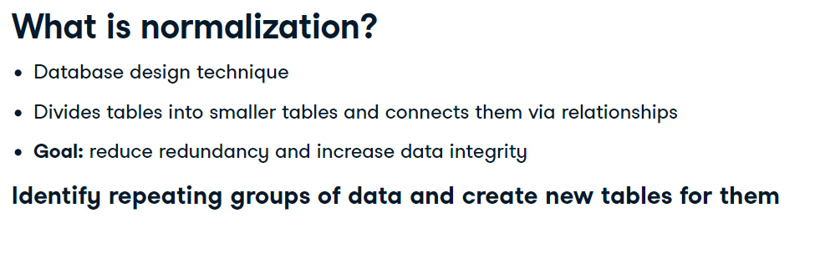 Book dimension of the star schema

Here's the book dimension in the star schema. What could be repeating here? Primary keys are inherently unique. For book titles, although there is possible repeat here, it is not common. On the other hand, authors often publish more than one book, publishers definitely publish many books, and a lot of books share genres. We can create new tables for them, and it results in the following snowflake schema:

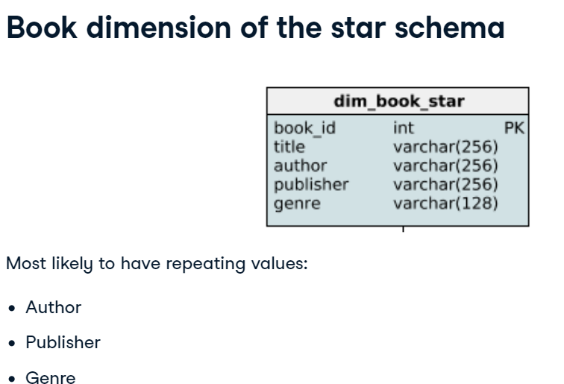 Do you see how these repeating groups now have their own table? 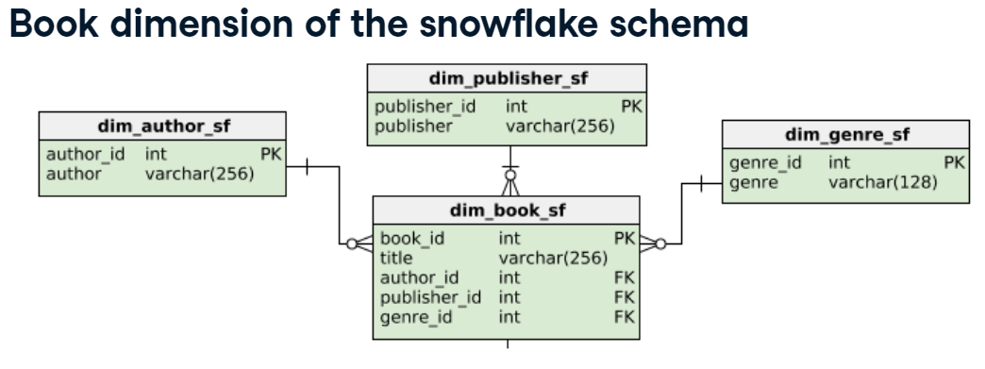 Store dimension of the star schema

On to the store dimension! City, states, and countries can definitely have more than one book stores within them.

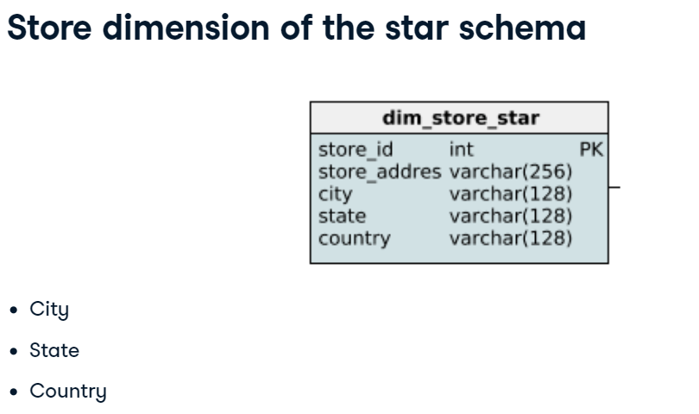 Here are the normalized dimension tables representing the book stores. Do you notice that the way we structure these repeating groups is a bit different from the book dimension? An author can have published in different genres and with various publishers, hence why they were different dimensions. However, a city stays in the same state and country; thus, they extend each other over three dimensions. 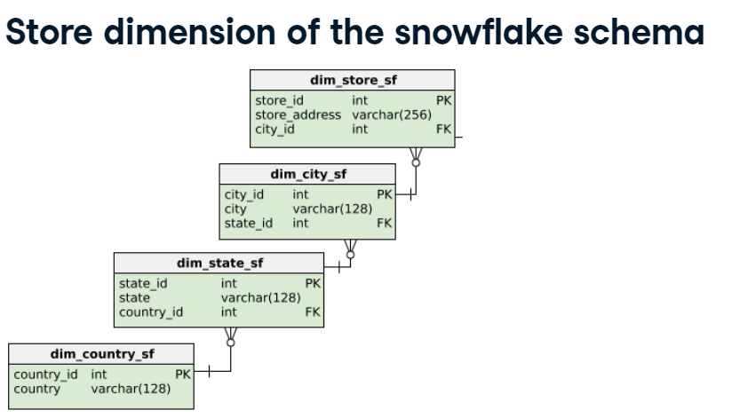

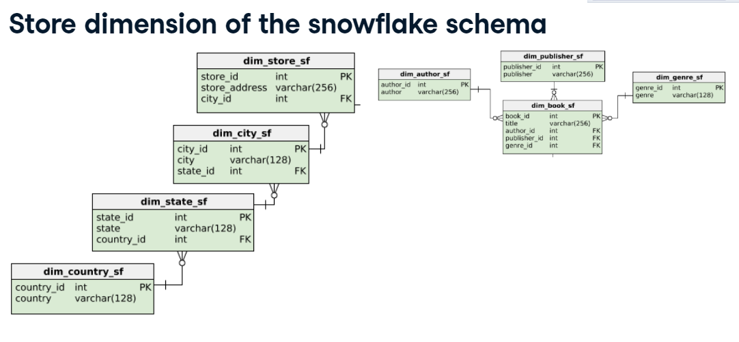 Time dimension

The same is done for the time dimension. A day is part of a month that is part of a quarter, and so on!

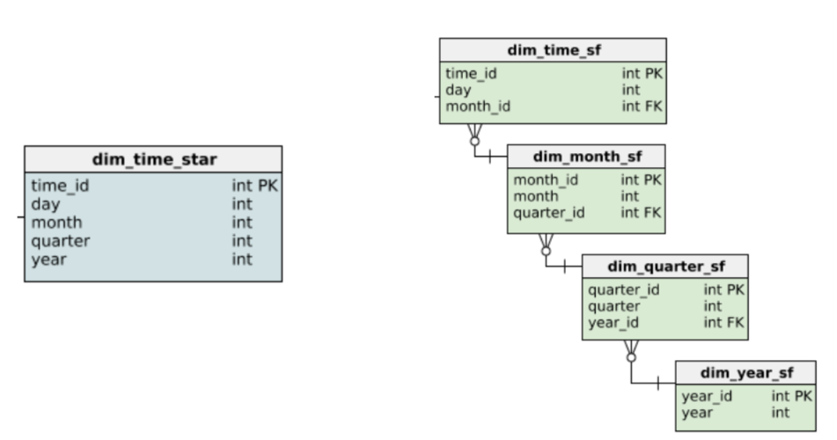

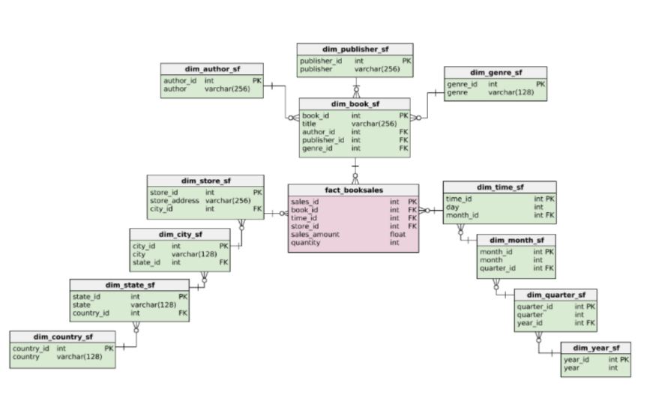

Star Schema vs. Snowflake Schema: 5 Critical Differences

1. Star schema dimension tables are not normalized, snowflake schemas dimension tables are normalized.
2. [Snowflake](https://trial.snowflake.com/?owner=SPN-PID-28241&utm_source=Xplenty&utm_medium=Blog&utm_campaign=SPIN) schemas will use less space to store dimension tables but are more complex.
3. Star schemas will only join the fact table with the dimension tables, leading to simpler, faster SQL queries.
4. Snowflake schemas have no redundant data, so they're easier to maintain.
5. Snowflake schemas are good for [data warehouses](https://www.integrate.io/glossary/what-is-data-warehouse/), star schemas are better for [datamarts](https://www.integrate.io/glossary/what-is-data-mart/) with simple relationships.

## **Normal forms**

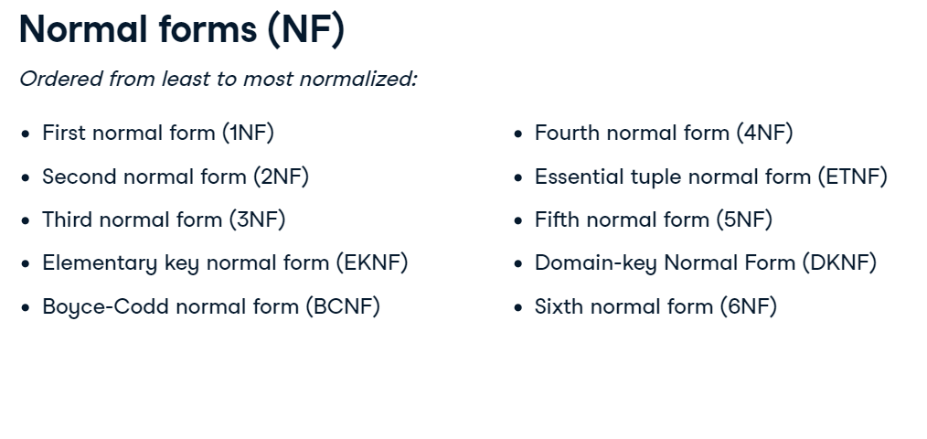 1NF rules

Let's begin with the first normal form. To comply with 1NF, each record must be unique and each cell must hold one value. Here's a simple table with student ids and emails, along with courses completed. All these rows are unique, but the courses_completed column has more than one course in two records.

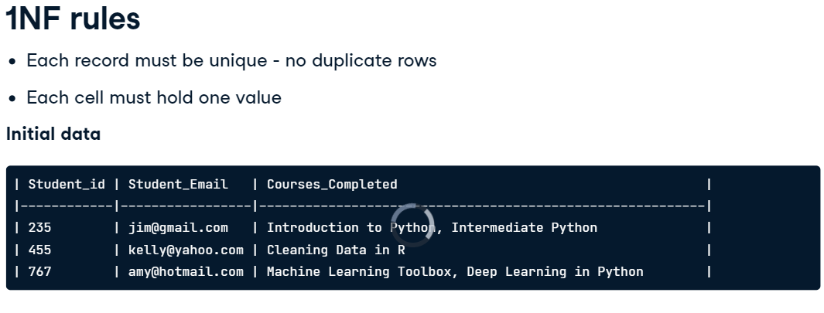 To rectify this, we can split the original table as such. Now, all the records are unique and each column has one value. 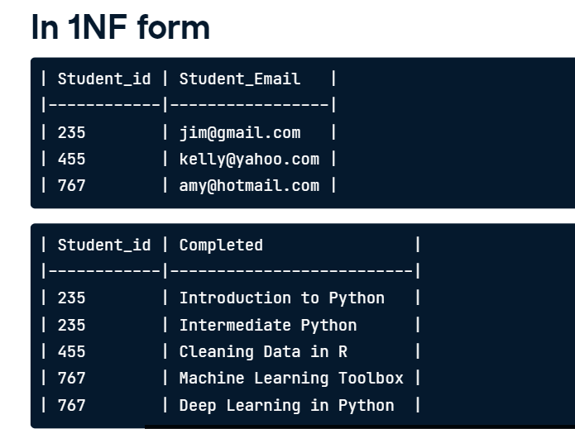 2NF

Next is 2NF, which must satisfy 1NF. Beyond that, if the primary key is one column, then the table is 2NF. A composite primary key is when a primary key is made up of two or more columns. If the table has a composite primary key, then each non-key column must be dependent on all the keys. Let's look at a concrete example. In this table, we have the student and course id as a composite primary key. We then review the other columns and their dependence on these two keys. First is the instructor, which isn't dependent on the student_id - only the course_id. Meaning an instructor solely depends on the course, not the students who take the course. The same goes for the instructor_id column. However, the percent completed is dependent on both the student and the course id.

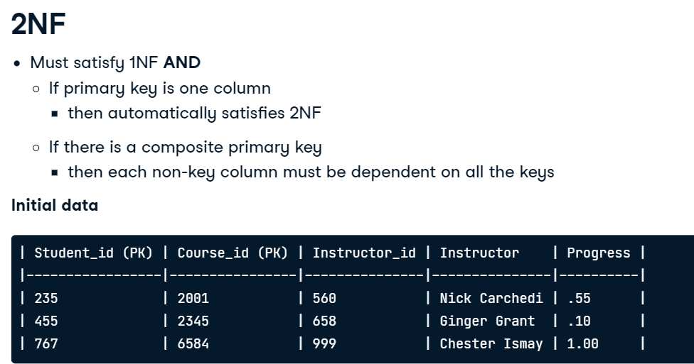 To convert it, we can create two new tables that satisfy the conditions of 2NF. 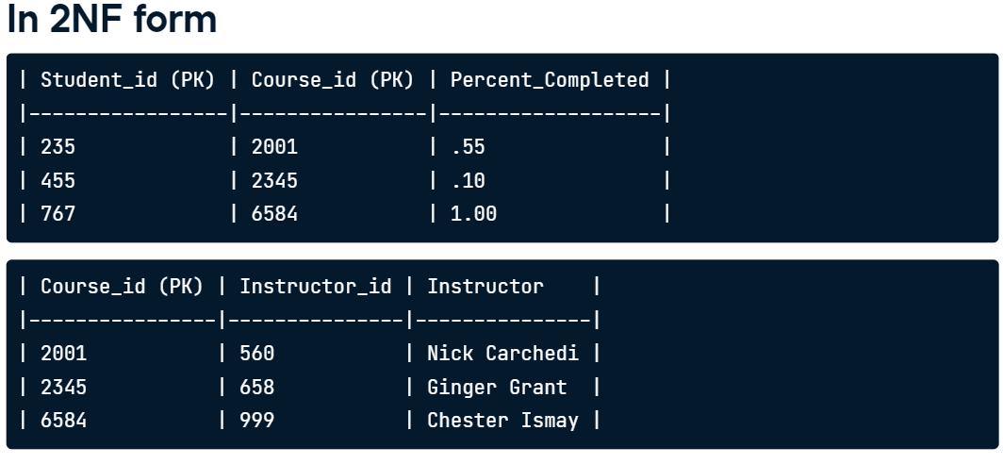 3NF

On to 3NF, where you might've correctly guessed requires 2NF to be satisfied. 3NF doesn't allow transitive dependencies. This means that non-primary key columns can't depend on other non-primary key columns. Let's take a look at an example. Course_id is the primary key so we can ignore this column. Instructor_id and Instructor definitely depend on each other. Tech does not depend on the instructor as an instructor can teach different technologies.

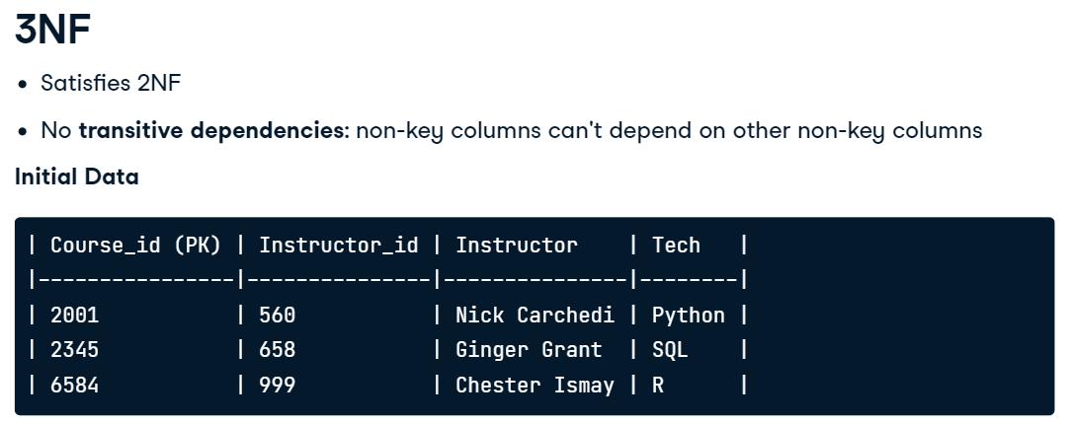 We can replace the table from before into these two tables to meet 3NF criteria. These tables have no transitive dependencies and they also meet 2NF as there are no composite primary keys.

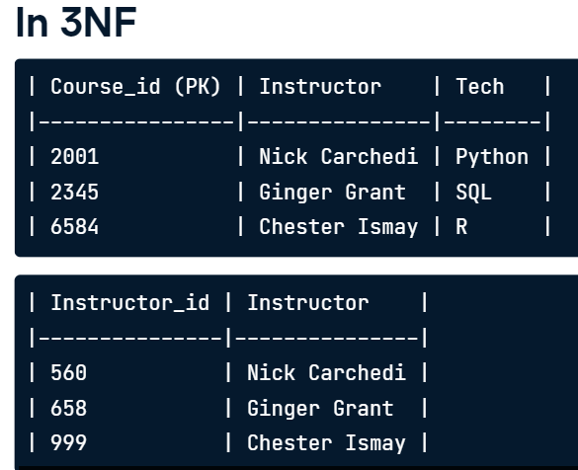 Data anomalies

We've covered these first three normal forms that increase in normalization. It's time to consider why we would want to put effort into normalizing a database even more? Why isn't 1NF enough? A database that isn't normalized enough is prone to three types of anomaly errors: update, insertion, and deletion.

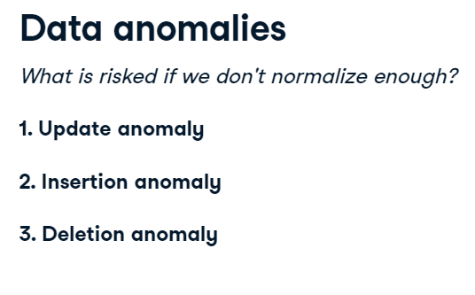

Update anomaly

An update anomaly is a data inconsistency that can arise when updating a database with redundancy. For example, take this simple table. It holds the id's and email of students, and their enrolled courses. If we want to update the email of student 520, we would have to update multiple records. It may sound easy to update multiple records, but it's risky because it depends on the user updating- if they remember this redundancy. And this is a simple example - as we scale, it's harder to keep track of these redundancies.

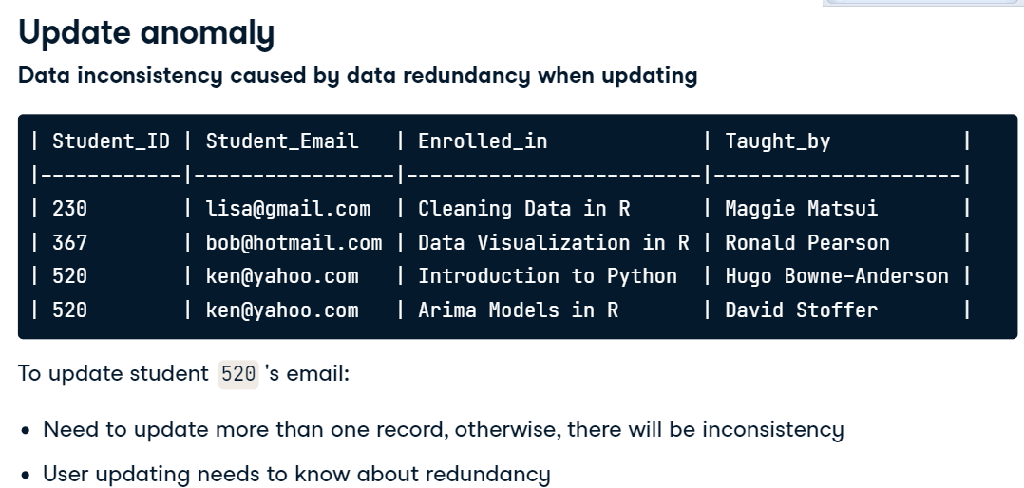

 Insertion anomaly

An insertion anomaly is when you are unable to add a new record due to missing attributes. For example, if a student signs up for DataCamp, but doesn't start any courses, they cannot be put into this database. The only exception is if the enrolled_in column can accept nulls. The dependency between columns in the same table unintentionally restricts what can be inserted into the table.

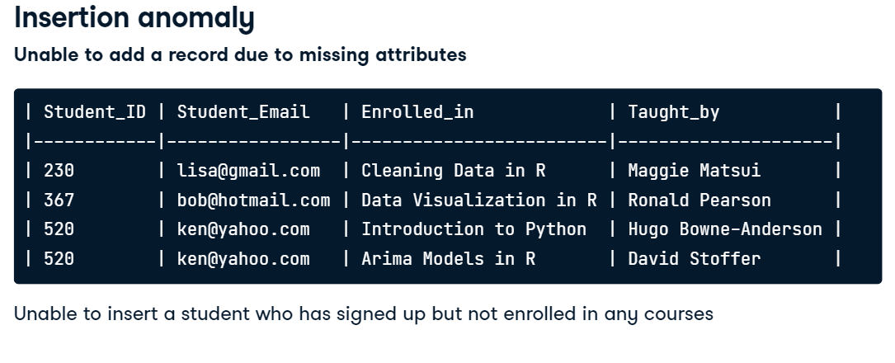  Deletion anomaly

A deletion anomaly happens when you delete a record and unintentionally delete other data. For example, if you were to delete any of these students, you would lose the course information provided in the columns enrolled_in and taught_by. This could be resolved if we put that information in another table.

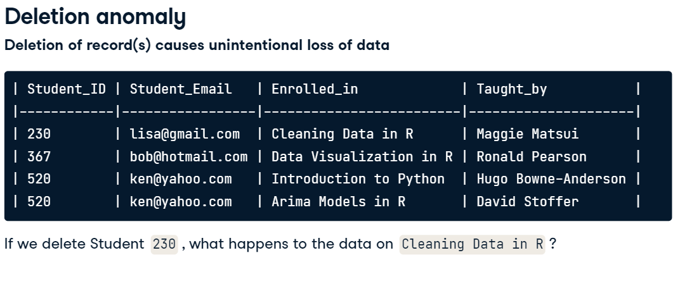

The more normalized the database, the less prone it will be to these anomalies. For example, most 3NF tables can't have an update, insertion, and deletion anomalies. This makes normalization sound great. But, don't forget the downsides of normalization from the last video! Remember those long queries? 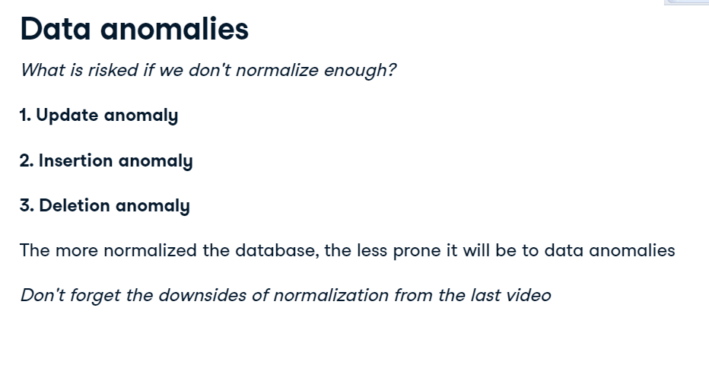

## Table partitioning

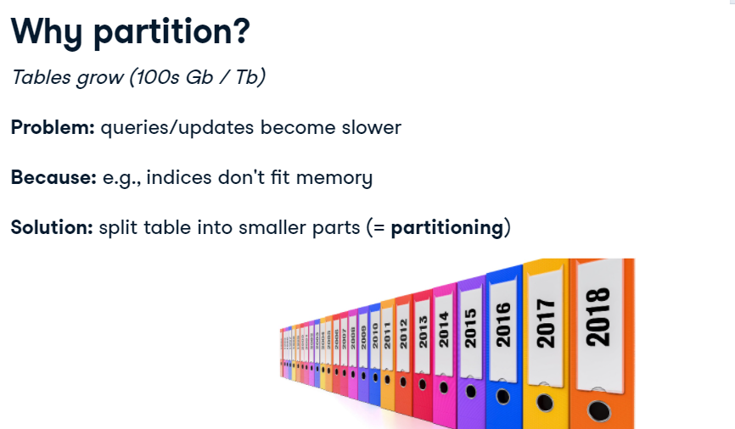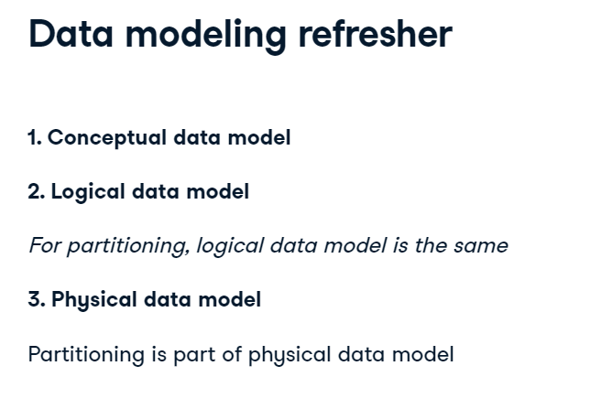

. Vertical partitioning

When we talk about partitioning, there are two different types of partitioning. The first one we'll introduce is vertical partitioning. You saw in the second chapter that to normalize a table, you can use foreign keys and create new tables. As you saw, it can help you reduce redundant data. Vertical partitioning goes one step further and splits up a table vertically by its columns, even when it's already fully normalized.

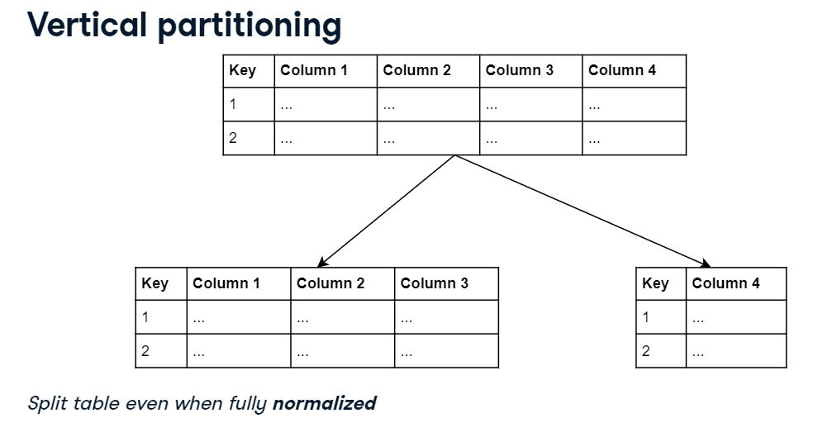

Vertical partitioning: an example

In this example, you start with a table containing product data. It has four columns. After vertical partitioning, you could end up with two tables: one for the first three columns, and another for the last column. We can link them through a shared key. Let's say the fourth column, containing a long description, is retrieved very rarely. We could store the second table on a slower medium. Doing this would improve query time for the first table, as we need to scan less data for search queries.

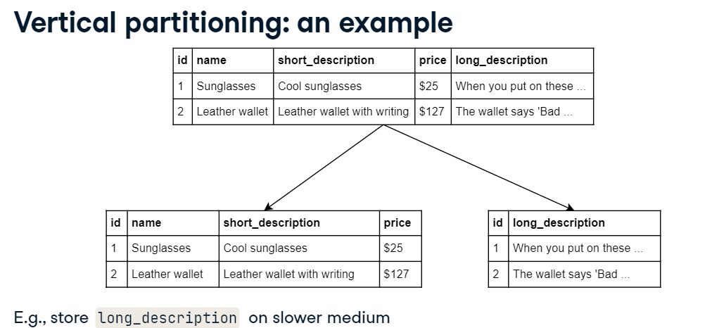

 Horizontal partitioning

For the remainder of this video, let's focus on the second type of partitioning: horizontal partitioning. Instead of splitting tables up over the columns, you can also split up tables over the rows. For example, you could split up data according to a timestamp. Specifically, all records related to 2019 could be in a separate partition from the ones of 2018.

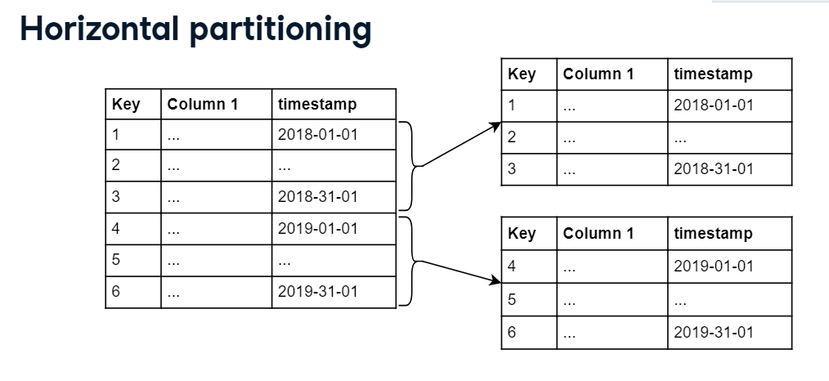Horizontal partitioning: an example

You could create partitions according to the timestamp, and partition them by quarter. Different SQL dialects have different ways of creating partitioned tables. In this example, we'll look at PostgreSQL, where you can use something called declarative partitioning since PostgreSQL 10. First, you add the PARTITION BY clause to your table creation statement. You pass it the column you want to partition by, 'timestamp' in our case. Next, you have to create the partitions. To do this, use the PARTITION OF clause to create tables for the specific partitions. You can specify rules to partition by in the same statement. For a timestamp, you could use particular ranges of values, like this. Finally, it's advised to add an index to the column you used for partitioning.

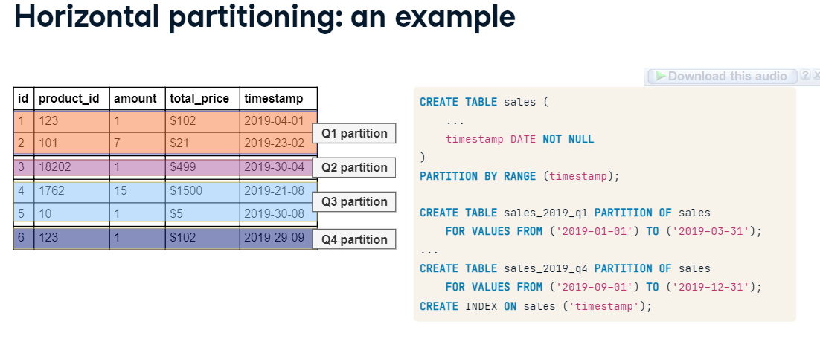

 Pros/cons of horizontal partitioning

Horizontal partitioning can help by optimizing indices, increasing the chance heavily-used parts of the index fit in memory. You could also move rarely accessed partitions to a slower medium. Both OLAP as OLTP can benefit from partitioning. There are some downsides though, as partitioning an existing table can be a hassle: you have to create a new table and copy over the data. Additionally, we can not always set the same type of constraints on a partitioned table, for example, the PRIMARY KEY constraint.

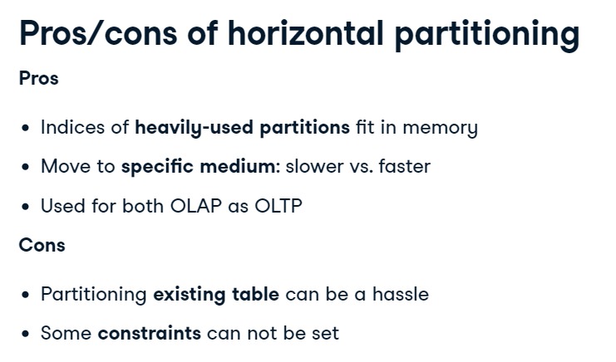

[Horizontal Partitioning in SQL Server | by Vaishali Goilkar | Medium](https://vaishaligoilkar3322.medium.com/horizontal-partitioning-in-sql-server-3d3b0e94f217)

 Relation to sharding

We can take partitioning one step further and distribute the partitions over several machines. When horizontal partitioning is applied to spread a table over several machines, it's called sharding. You can see how this relates to massively parallel processing databases, where each node, or machine, can do calculations on specific shards.

